

Poverty and Neighbourhood Renewal in West Cornwall

Eldin Fahmy, Dave Gordon and Sarah Cemlyn
University of Bristol

Paper presented at the Social Policy Association Annual Conference, Nottingham – August 2002.
Full report available at: www.bris.ac.uk/poverty/region.htm

ABSTRACT

This paper addresses the issues and challenges involved in tackling deprivation and neighbourhood decline in remote rural areas. The paper is based upon empirical research into Neighbourhood Renewal in West Cornwall and comprised three phases: (1) the identification and mapping of deprivation; (2) consultation with “key stakeholders” to identify the priorities and challenges faced by deprived neighbourhoods, and; (3) an audit of community services, resource flows and community organisation.

This paper focuses upon the challenges of identifying and mapping deprivation in remote rural communities within the context of the Neighbourhood Renewal framework. Drawing upon the consultation data the paper also considers the unique problems faced by rural residents and how these can be addressed from a multi-agency perspective. The paper concludes by outlining some of the key policy recommendations for future practice in multi-agency working in deprived rural communities.

INTRODUCTION

The need for better information at a neighbourhood scale is increasingly acknowledged as vital in tackling poverty, deprivation and social exclusion. Local surveys, community audits and qualitative research are increasingly being used by local authorities in order to draw up ‘local poverty profiles’ which can contribute to the development of anti-poverty strategies which meet the distinctive needs of individual localities, and to ‘fill the gaps’ in existing national data sources (LGA, 2001). Identifying areas of priority need is also central to advancing local strategies for combating poverty and social exclusion within the context of the Neighbourhood Renewal framework. The development of more comprehensive local small area statistics is recognised as a key priority within the Neighbourhood Renewal framework, as acknowledged within the report of the Social Exclusion Unit’s Policy Action Team 18, Better Information (SEU, 2000).

The need for more detailed data at a small area level is amplified in rural areas where poverty is often ‘hidden’ and spatially dispersed, and where deprivation is frequently manifested in different ways. This paper seeks to inform the development of local strategies for combating poverty, and neighbourhood decline by contributing towards the advancement of an effective methodology for identifying and measuring deprivation at the small area level, especially in rural communities. Whilst the accurate identification of need is important in all work targeting deprivation and social exclusion, it has a particular relevance for the development of Local Neighbourhood Renewal Strategies in the 88 most deprived districts supported by the Neighbourhood Renewal Fund (NRF). There is also a need for further work focusing upon the distinctive challenges posed in the identification and mapping of poverty in remote rural communities. The research outlined in this paper contributes towards this objective.

The central focus of this paper is upon the spatial mapping of deprivation in the West Cornwall local authority districts of Kerrier and Penwith. A detailed map of the region is given in the Appendix. The challenges involved in the identification and measurement of rural poverty are discussed in Section 1. Section 2 outlines the methodology used and some of the findings from the quantitative phase of the research, using small area statistics derived from the 1991 Census of Population in order to identify NRF priority neighbourhoods. However, this research was also part of a larger project contributing towards the development of an effective local strategy for community regeneration. Addressing this wider goal involved the adoption of a multi-method research strategy incorporating qualitative fieldwork alongside the statistical analyses, in order to explore in greater depth the problems facing deprived communities and the opportunities and obstacles involved in the delivery of a successful local neighbourhood renewal strategy. The relationship between the qualitative fieldwork and the initial statistical work is discussed in Section 3.

1. RURAL DEPRIVATION IN THE UK

At the end of the twentieth century poverty remains a major and deep-rooted problem both in the UK and across western industrialised nations. Indeed academic research within the UK reveals growing levels of poverty, inequality and social exclusion since the 1970s (eg. Mack and Lansley, 1985; Gordon and Pantazis, 1997). Alongside this increasing social polarisation, the spatial concentration of poverty in particular neighbourhoods and on certain estates has also increased, despite a raft of national initiatives aimed at combating poverty since the 1960s. Although such initiatives have generally been targeted at inner city areas and (post)industrial, urban communities, growing levels of poverty, and the increasing spatial concentration of deprivation, can be found in all localities - including rural communities and traditionally ‘affluent’ areas (see eg. Chandola et al., 2000; Chapman et al., 1998).

The increasing acknowledgement of the problems faced by rural communities, and of the growth in rural poverty in recent years, is reflected in changes to the DETR’s Indices of Local Deprivation (ILD). The 2000 ILD accords greater emphasis to access to services and, since many rural residents have poor access to essential services, to ‘deprivation’ in remote rural areas (DETR; 1998, 2000). Unfortunately this approach conflates two distinct understandings of deprivation. Areas with poor access to services, often remote rural areas, do not necessarily contain large proportions of ‘poor’ people. It thus makes little scientific sense to include both measures within an overall national index, as the 2000 Index of Multiple Deprivation does.

These observations illustrate the difficulties involved in developing national indicators of deprivation capable of accurately and reliably measuring poverty, deprivation and area decline in both urban and rural contexts. The nature of deprivation in rural areas often differs significantly from that of industrial conurbations and inner-city communities and this should inform subsequent policy responses. Poor access to jobs and services due to isolation, transport costs and inadequate public transport are far bigger issues for rural than large-scale urban communities. Whilst rural areas are generally characterised by lower levels of registered unemployment, there are pockets of high unemployment and other employment disadvantage in rural areas, particularly in isolated locations. The seasonality of work together with low wages and low rates of economic activity, are also major problems for many rural areas.

Similarly, housing deprivation in rural areas is often manifested in increasingly unaffordable housing stock and not simply in its physical dilapidation. The demand for owner-occupied housing is often very high, partly due to new household formation and the tendency towards smaller households but also as a result of demand from relatively affluent incomers and second-home buyers. However, the supply is often restricted and prices tend to be high, generating problems of affordability for those on low or middle incomes. Furthermore, the proportion of social housing to rent is low in rural areas, not only because of right-to-buy sales but also because of historically lower rates of Local Authority and Housing Association provision. This restricts further the choice available to those seeking affordable housing in rural areas.

However, rural areas themselves differ considerably as a result of their unique histories and development. There are marked differences between those living in remote rural areas and those nearer to conurbations. Within rural England as a whole, low incomes, educational deprivation, poor health and unemployment are greater in remoter rural areas (and areas that are particularly reliant on agriculture) than in more accessible ‘commuter’ areas (Countryside Agency, 2000). The Southwest region and, especially, Cornwall, performs poorly on all four of these scales.

2. Mapping deprivation in west cornwall

2.1 Methodology

Measures of deprivation based upon 2000 ILD statistics use a range of ward level indicators which are not entirely adequate in a remote rural setting. In addition to shortcomings in some of these measures themselves in capturing deprivation in a rural context, ward level statistics are a rather crude measurement tool when applied to rural areas. Partly as a result of its unique history and economic trajectory, the settlement form in west Cornwall is highly nucleated so that relatively affluent and highly deprived communities are often located within the same ward. This means that ward-level statistics based upon ‘average’ scores across a ward do not reflect the true extent of deprivation, even in those areas of relatively high population densities (ie. the major towns). In the most remote rural areas of west Cornwall ward-level statistics are entirely inappropriate in locating very small clusters of often acute deprivation. A primary task of the research described in this paper was therefore to identify the poorest neighbourhoods in West Cornwall at small area level using areal units smaller than electoral wards.

The measurement of deprivation at the sub-ward level is constrained both by data limitations and by the appropriateness of deprivation indicators in a rural context. The 1991 Census provides the only reliable data at the sub-ward level for the whole of the UK. However, none of the 1991 Census questions was specifically designed to measure deprivation so any Census-based index will be comprised of variables which are at best proxy measures of deprivation (Bruce et al, 1995). Moreover, since such indices need to be nationally representative, their construction tends to under-emphasise the distinctive needs of people living in remoter rural areas. However, within these constraints indicators were selected on the basis of their appropriateness in a rural context. Access to a car is a key dimension of access to community services in rural areas, and is probably a more useful indicator than the presence of absence of services within a defined area given the paucity of public transport in many rural areas. Similarly, the proportion of households without central heating is a better guide to housing deprivation in rural areas than physical overcrowding.

Seven indicators derived from the 1991 Census of Population were finally selected. These measures approximate to the six ‘domains’ of deprivation (plus the supplementary child poverty index) identified by the DETR and included within the 2000 ILD:

- Poverty rate (Income)
- Child poverty rate (Supplementary)
- Unemployment rate (Employment)
- Percent of people aged 18 and over with no post school qualifications (Education)
- Limiting Long Term Illness/Disability rate (Health)
- Percent of households with no central heating (Housing)
- Percent of households with no car (Access to services)

On the basis of these measures an index of cumulative deprivation was constructed. First, the scores for each Enumeration District were ranked for each measure. Secondly, the different ‘domains’ were weighted to broadly reflect the weightings used in the construction of the DETR’s 2000 Index of Multiple Deprivation (IMD). This ensured that the final index was constructed in a similar way to the 2000 IMD used to identify priority districts eligible for Neighbourhood Renewal funding. Finally, Enumeration Districts were then ranked according to their score on this index and a cumulative population variable constructed. On this basis it was possible to identify the most deprived Enumeration Districts for any population threshold. It was decided by the steering committee that the research team should identify the poorest areas in West Cornwall in which a third (33%) of the population lived. These represented the primary target areas for Neighbourhood Renewal funding.

An interpolation technique known as Inverse Distance Weighting (IDW) was used to map the distribution of deprivation for each of the individual indicators. There are many advantages to taking spatial data beyond a purely descriptive display method. Deprivation is not constrained by Census boundaries, that is, deprivation usually does not dramatically fall from high levels on one side of an Enumeration District boundary to low levels on the other. IDW interpolation is a mathematical process used to estimate values between known point observations. This procedure ‘smoothes’ the gradations in levels of deprivation across Enumeration Districts to generate a more realistic model of deprivation.

Figure 1: The Inverse Distance Weighting Technique

(1)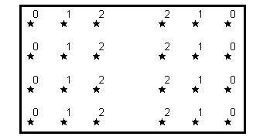(2)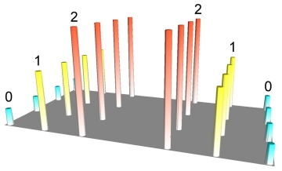(3)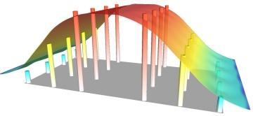
(1)
©Northwood Geoscience

In Figure 1 (above), illustration (1) 24 points are arranged regularly with attribute values ranging from 0 to 2 (Tile 1). Any numeric attribute can be represented in three dimensional form, as depicted in Tile 2. This image is actually a rendered grid generated using IDW interpolation by sampling only one data point and using a very small display radius equal to the width of a single column. However, grids are usually used to build a continuous surface that connects data points in space, effectively removing gaps in the representation of data. IDW achieves this by generating a moving average or ‘smoothing’ of the data (Tile 3).

2.2 Findings

High levels of poverty are endemic across much of West Cornwall. Figure 1 (below) shows the poverty index scores for each Enumeration District in west Cornwall for the upper quartile of the distribution. For each Enumeration District the score represents the percentage of households living in poverty as defined by the Breadline Britain in the 1990s Survey (Gordon and Pantazis, 1997) and applied to the 1991 Census data (see Gordon, 1995) . Figure 2 (below) shows the distribution of poverty in West Cornwall where those areas with the highest cumulative index scores (ie. the upper quartile of distribution) are coloured red (most deprived) to yellow (slightly less deprived). A detailed map of the region is given in the Appendix. Poverty is concentrated in much of west Penwith (especially the coastal towns of Penzance and Newlyn, St. Ives, St. Just, and Hayle), as well as in the Camborne, Pool and Redruth area, and the Lizard peninsula.

Figure 2: Poverty rate in West Cornwall by Enumeration District

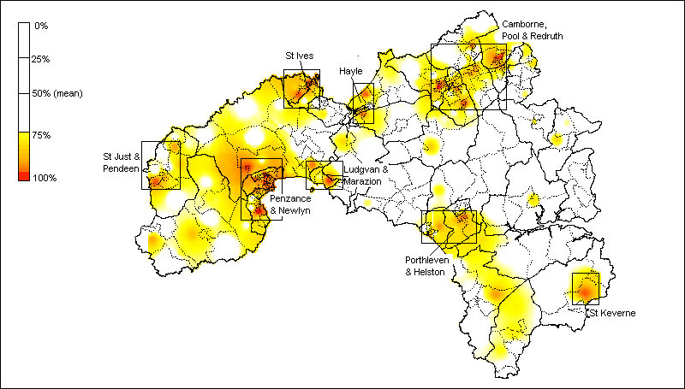

A similar pattern is evident in relation to health inequalities. The Standardised Illness Ratio (SIR) measures the incidence of morbidity standardised by age and sex, where a score of 100 represents the average health of the population. Thus a score of 167 across an Enumeration District means that residents are 67% more likely to experience a “long term illness, health problem or handicap which limits their daily activities or the work they can do” compared with the average for England and Wales.

As Figure 3 (below) shows, ill health in West Cornwall is concentrated mainly in north Kerrier. The Enumeration Districts in West Cornwall with the highest scores (ie. within the upper quartile of the distribution) are predominantly in the Camborne, Pool, Redruth area. However, smaller pockets of ill health are also evident in the large coastal towns of Penzance and Newlyn, St. Ives, and Hayle, as well as in the Pendeen area, and the Lizard peninsula.

Figure 3: Standardised Illness Ratio in West Cornwall by Enumeration District

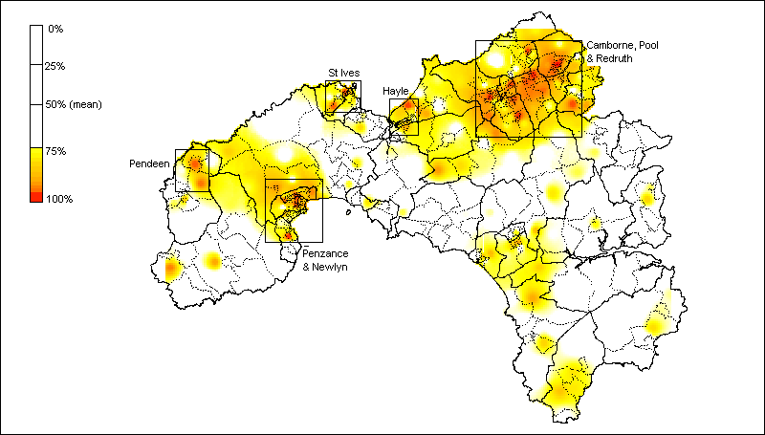

It was then possible to map deprivation at a small area level using a cumulative index of deprivation (as described above). As Figure 4 (below) shows the most significant concentrations of deprivation produced by this procedure are in the larger settlements. Mapping deprivation at Enumeration District level also reveals smaller pockets of deprivation in rural settlements such as the Lizard area, Pendeen, and the Land’s End area.

Figure 4: Cumulative index of deprivation in West Cornwall

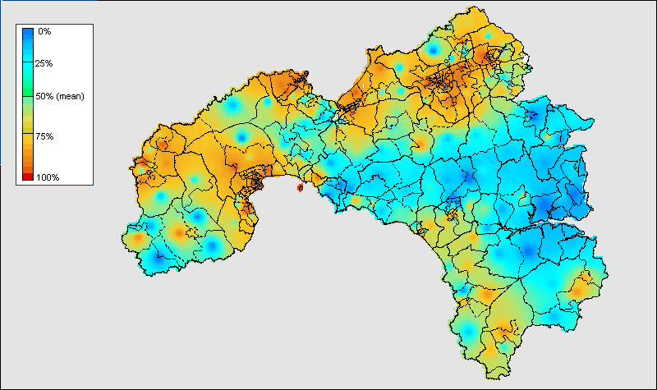

However the highly seasonal nature of work in these rural areas (particularly tourism and crop picking), combined with the influence of second home ownership, may obscure the ‘true’ extent of need in statistical analysis. This point emphasises the importance of other survey sources and qualitative research as a means of cross-validating and triangulating these census data. One such source is the Experian neighbourhood classification developed as part of the Great Britain MOSAIC project. GB MOSAIC classifies households into 52 distinct ‘lifestyle types’ which comprehensively describe their socio-economic and socio-cultural behaviour.

Using the GB MOSAIC profiles, it was possible to construct variables which broadly correspond to indicators of rural poverty. The following clusters (or household types) were identified as pertinent to the investigation of rural poverty: low rise pensioners; low rise subsistence; peripheral poverty, and; rural disadvantage. Households defined as “poor consumers” using the GB MOSAIC classification are concentrated largely in west Penwith (especially in the St. Just area), as well as in north Kerrier (principally in Camborne and Redruth), as Figure 5 (below) shows.

Figure 5: “Poor Consumers” in West Cornwall by postcode sector, 2000

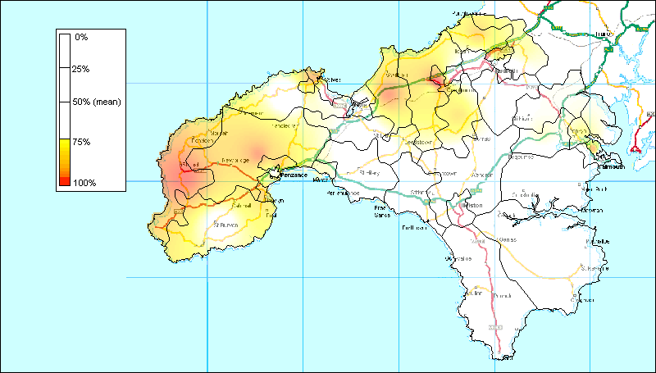

Whilst this broadly accords with the cumulative index developed on the basis of Census data, smaller predominantly rural settlements are overlooked using a classification based upon GB MOSAIC. This inconsistency between Census based and GB MOSAIC based approaches is partly a result of the larger spatial scale of UK postal sectors in comparison with Enumeration Districts, which means that smaller pockets of deprivation within otherwise relatively affluent areas are often missed. However, it also reflects the different priorities of market research, which focus upon predicting consumer behaviour rather than upon the scientific measurement of poverty and social exclusion. Geo-demographic market researchers are primarily interested in the location of middle income and richer social groups, whereas social scientific research has often concentrated on mapping the distribution of poorer social groups.

3. CONSULTATION WITH STAKEHOLDERS

Inevitably however the analysis of census data is a crude tool for exploring the extent and dynamics of deprivation in remote rural settings. Shucksmith (1990) and others have argued the need for qualitative and local survey work to provide better information about rural deprivation, and the application of multiple methods to research and policy problems is an important means of overcoming the inherent weaknesses of ‘mono-method’ approaches. Rather than addressing the same aims, methods are combined in this study in order to explore different levels of enquiry and in order to address different aspects of the same problem. Combining qualitative and quantitative methods in this way gives both depth and breadth to research findings by drawing upon the complementary strengths of these approaches (see eg. Brannen, 1992; Hammersley, 1992; Fielding and Fielding, 1986).

Further qualitative fieldwork with ‘key stakeholders’ in the regeneration process was undertaken in order to explore: the extent to which the statistical analyses presented above reflected public perceptions of the neighbourhoods in greatest need; the problems faced by deprived neighbourhoods and their causes, and; participants’ perspectives on potential solutions. As such they provide a more finely textured account of the problems facing the region (eg. in relation to income and employment deprivation, housing need, and ill health) than could be achieved solely on the basis of analysis of census data. In the process these data contribute towards the development of locally based strategies for combating poverty and area deprivation. ‘Off the peg’ solutions to problems of neighbourhood deprivation are unlikely to be effective in the Cornish context given its unique history and development.

Thirty one semi-structured interviews with 37 representatives of the statutory, voluntary and community sectors were conducted by the research team. The face-to-face interviews were supplemented by a further 14 telephone interviews. Virtually without exception the neighbourhoods identified by participants were all included in the clusters defined by the mapping exercise and so there was a remarkable degree of convergence between the findings from these stages of the research, and between the methods which constitute them. There is an element of serendipity here. Addressing inconsistencies between findings generated by different methods is a key issue in methodological triangulation (Bryman, 1988).

Nevertheless these findings accord with larger, survey-based approaches which have sought to determine the extent to which areas identified as being disadvantaged by existing indices are the same areas that would be identified by their residents. Burrows and Rhodes (1998) used data from the 1994/95 Survey of English Housing to explore the socio-economic characteristics of those expressing high levels of area dissatisfaction, and following Dorling (1996) estimated the spatial distribution of such residents using 1991 Census data. These estimates of area dissatisfaction were then compared with common measures of area deprivation. These analyses revealed a close correlation between maps of neighbourhood deprivation generated by existing indices and data generated by exploring residents own views of their local areas.

Many respondents referred to the proximity of poorer areas to more affluent areas and the consequent potential for masking of these smaller pockets of deprivation in statistical terms. This perception reinforces the case for statistical analyses at a sub-ward level. However a number of concerns were also raised about the identification of deprived areas. Firstly, some participants were concerned that defining particular areas as ‘deprived’ feeds into a process of labelling, stigmatisation and lowered expectations which studies show can have a further detrimental effect on the prospects of an area and undermine other benefits of regeneration (see eg. ACU, 1999; Dean and Hastings, 2000). Other participants considered it unhelpful to identify some neighbourhoods rather than others as deprived because they saw the whole area as deprived and in need of renewal.

The interview data also facilitated a more detailed, richer account of the problems facing deprived neighbourhoods in West Cornwall. As such they enabled the research team to explore highly complex processes which are not always amenable to quantification and statistical analysis. For example, the manifestations of housing deprivation in remote rural areas are often quite distinct from the problems facing urban communities, and especially inner city areas. A range of housing-related indicators are available in the 1991 Census of Population, with household overcrowding typically being adopted as a key indicator of housing deprivation, for example in the 2000 ILD (see DETR, 2000b). However, household dynamics in remote rural areas are such that household overcrowding is rarely a significant problem, even in the most deprived neighbourhoods, and was not referred to by any of our interviewees.

The proportion of households without central heating is a better guide to housing deprivation in rural areas than physical overcrowding. However, this indicator measures only one aspect of housing deprivation. The multi-dimensionality of housing deprivation is better reflected in the qualitative fieldwork which builds upon and extends the statistical analyses. A range of further housing-related issues were referred to by research participants, such as the shortage of affordable private housing and inadequate social housing provision, poor quality housing, and the impact of incomers and second homes on house prices. Similar observations are pertinent in relation to other dimensions of deprivation such as employment. At 11.4%, unemployment rates in West Cornwall as measured by the 1991 Census were considerably higher than across the UK as a whole (9.1%) and the southwest region (8.1%). However these figures disguise the extent of seasonality and job security, the effects of low wages and declining real incomes for disadvantaged groups, and the consequences of skills mismatches in relation to emerging industries such as information and communication technologies. These were just some of the issues raised by research participants, summarised in Box 1 (below).

Box 1: Problems faced by deprived neighbourhoods - research participants perspectives

- Employment: Seasonality and insecurity; low wages; declining real income for disadvantaged groups; skills mismatch in relation to emerging industries
- Housing and environment: Lack of affordable private housing; poor quality housing (damp, inadequate heating and insulation, physical dilapidation); impact of incomers and second homes on house prices; shortage of social housing; adverse impact of tourism on the environment; contamination of former industrial land
- Education and training: Lack of opportunities for higher education; loss of apprenticeship system; lack of opportunities generally for young people and associated lack of hope; resulting outflow of young people from the area
- Services and facilities: Poor public transport; lack of available, flexible and affordable childcare; difficulties of access for disabled people; insufficient play, leisure and cultural facilities; shortage of youth workers; in-migration pressures
- Health: Isolation, especially for older, single, and disabled people; mental health issues including postnatal depression; long term ill health and shortage of relevant provision; difficulties of access to primary health services, and emergency and specialist services; drug and alcohol problems; teenage pregnancies; shortage of accessible and confidential sexual health services
- Crime and anti-social behaviour: Problems of vandalism and anti-social behaviour experienced by older residents on some estates; fear of crime disproportionate to the incidence of crime; racism experienced by asylum seekers and minority ethnic groups including Gypsies and Travellers

conclusion

Since the 1960s, there have been numerous initiatives aimed at tackling the broader problems of poor neighbourhoods. Cornwall has received funding under most regeneration and regional development schemes operating since the Second World War (see Kain and Ravenhill, 1999). However in the past, the hidden and dispersed nature of poverty in rural areas has often made rural poverty difficult to address through area-based schemes and community development (Shucksmith, 2000). In comparison, the Neighbourhood Renewal framework offers greater flexibility in the identification and targeting of regeneration spending to meet the needs of deprived communities aided by the development of small area, ward-level statistics.

In the rural context, however, there is a need for area statistics at a smaller still spatial scale. Currently only the Census of Population provides reliable socio-demographic data at the sub-ward level. Analysing the 1991 Census derived poverty index (see Section 2, above) at a sub-ward level significantly improves the identification of rural poverty in West Cornwall. Overall, according to this measure 10,700 (18.2%) of households in West Cornwall were poor in 1991. Seven wards in West Cornwall fall within the most multiply deprived wards in England and Wales according to the 2000 Index of Multiple Deprivation, and on this basis were identified as a NRF priority area. Based upon 1991 Census estimates these wards contain one third (33%) of all poor households in West Cornwall, with over one fifth (22%) of households in these areas living in poverty. Over one quarter (27%) of the population of West Cornwall lived in these wards. However using an identical population threshold the priority areas identified at an Enumeration District (ED) level using the procedure described above (Section 2) contained over two fifths (42%) of all poor households in West Cornwall, with more than one in four (28%) households in these areas living in poverty, as Figure 6 (below) shows.

Figure 6: Priority neighbourhoods in West Cornwall at ward and ED level: 27% population threshold
NOTE:
% of poor = percentage of all poor households in West Cornwall within priority areas.
% within PA’s = percentage of households within Priority Areas which are poor.

Nonetheless even at this spatial scale the majority of poor households are outside the priority areas, and the majority of households within the priority areas are not poor as defined by this measure. Area based interventions are thus likely to benefit non-poor residents as much as those living in poverty, and will exclude more poor people than they serve. The development of local partnerships for Neighbourhood Renewal represents a considerable advance upon earlier areas based schemes in the development of a more strategic, ‘joined up’ approach to neighbourhood regeneration. However on their own area based initiatives are inadequate mechanisms for combating poverty, and need to be supplemented by anti-poverty measures which focus upon improving the circumstances of poor individuals. Subjecting all existing and proposed policies to audit in respect of their likely impact upon people on low incomes in rural areas (‘rural proofing’) is an important element in the development of local anti-poverty strategies (LGA, 1998). The mainstreaming of local strategies so that resources are targeted at those most in need is also crucial (see eg. Alcock et al., 1999). However limitations on what can achieved at a local level need to be acknowledged. Local initiatives alone cannot provide solutions without a commitment to the type of basic structural changes at regional, national and international levels necessary to eliminate poverty.

references

ACU (Active Community Unit) (1999) Report of the Policy Action Team on Community Self-Help. London: Social Exclusion Unit

Alcock, P., Barnes, C., Craig, C., Harvey, A. and Pearson, S. (1999) What Counts? What Works? Evaluating anti-poverty and social inclusion strategies London: Improvement and Development Agency

Brannen, J. (1992) “Combining Qualitative and Quantitative Approaches: An overview” in Brannen, J. (Ed.) Mixing Methods: Qualitative And quantitative research. Aldershot: Avebury

Bruce, A., Gordon, D. and Kessell, J. (1995) “Analysing Rural Poverty” Local Government Policy Making 22(1): 16-23

Bryman, A. (1988) Quality and Quantity In Social Research London: Unwin Hyman

Burrows, R. and Rhodes, D. (1998) Unpopular places? Area disadvantage and the geography of misery in England. Bristol: The Policy Press.

Chandola, T., Lloyd, M., Noble, M., Wright, G. and Wigglesworth, R. (2000) Rural Deprivation: An analysis of the indices of deprivation 2000 for rural areas. Oxford: University of Oxford

Chapman, P., Phimister, E., Shucksmith, M., Upward, R. and Vera-Toscano, E. (1998) Poverty and Exclusion in Rural Britain: The dynamics of low income and employment. YPS/Joseph Rowntree Foundation

Countryside Agency (2000) The State of the Countryside, 2000. Wetherby: Countryside Agency

Dean, J. and Hastings, A. (2000) Challenging Images: Housing estates, stigma and regeneration Bristol: Policy Press / Joseph Rowntree Foundation

DETR (1998) Guidance on the Methodology for Multi-Modal Studies. London: DETR.

DETR (2000a) Indices of Deprivation 2000: Regeneration Research Summary 31. London: DETR

DETR (2000b) Measuring Multiple Deprivation at the Small Area Level: The Indices of Deprivation 2000. London: DETR

Dorling, D. (1996) “Identifying disadvantaged areas: Health, wealth and happiness” Joseph Rowntree Foundation Area Regeneration Position Paper. York: JRF

Fielding, N. and Fielding, J. (1986) Linking Data: The articulation of qualitative and quantitative methods in social science. Beverly Hills, California: Sage

Gordon, D. (1995) Census Based Deprivation Indices: Their Weighting and Validation, Journal of Epidemiology and Community Health 49 (Suppl 2): 39-44.

Gordon, D. and Loughran, F. (1997) Child Poverty and Needs Based Budget Allocation, Research, Policy and Planning 15(3): 28-38.

Gordon, D. and Pantazis, P. (Eds.) (1997) Breadline Britain in the 1990s. Aldershot: Ashgate

Hammersley, M. (1992) ‘Deconstructing the Qualitative - Quantitative Divide’ in Brannen, J. (Ed.) Mixing Methods: Qualitative and quantitative research. Aldershot: Avebury

Kain, R. and Ravenhill, W. (Eds) (1999) A Historical Atlas of South-West England. Exeter: University of Exeter Press.

Lee, P., Murie, A. and Gordon, D. (1995) Area Measures of Deprivation. A study of Current Methods and Best Practices in Identification of Poor Areas in Great Britain. University of Birmingham: Birmingham.

LGA (Local Government Association) (2001) All Together Now? A survey of local authority approaches to anti-poverty and social inclusion LGA Research Report No. 20. London: LGA

LGA (Local Government Association) (1998) Tackling Rural Poverty and Social Exclusion: The role of local authorities London: LGA

Mack, J. and Lansley, S. (1985) Poor Britain. London: Allen and Unwin

SEU (Social Exclusion Unit) (2000) Report of Policy Action Team 18: Better information. London: SEU

Shucksmith, M. (2000) Exclusive Countryside? Social Inclusion and Regeneration in Rural Areas York: Joseph Rowntree Foundation

Shucksmith, M. (1990) The Definition of Rural Areas and Rural Deprivation: Report to Scottish Homes. Edinburgh: Scottish Homes
APPENDIX: The Local Authority Districts of Kerrier and Penwith

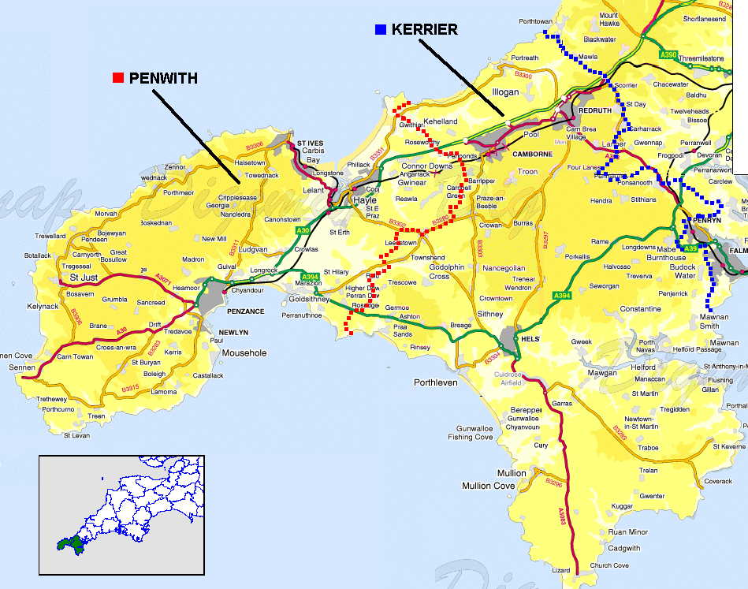

The poverty and child poverty measures are derived from the 1990 Breadline Britain survey (Gordon and Pantazis, 1997) and applied to 1991 Census data (Gordon, 1995; Gordon and Loughran, 1997). These measures are considered to be amongst the most accurate available by many authors (eg Lee et al, 1995; Burrows and Rhodes, 1998).
These were: poverty (0.2); child poverty (0.2); unemployment (0.2); standardised illness ratio (0.12); post-school educational qualifications (0.12); central heating (0.08), and; access to a car (0.08).
In the Breadline Britain in the 1990s survey poverty was defined scientifically using the consensual method e.g. in order to be poor a household had to have both a low income and a standard of living that was below the minimum acceptable to the majority of the British population.

