Residential Facilities Management Postal Policy

Reference: | RFO-PD-003
Version: | 5.0
Effective Date: | 18th September 2023
Document Type: | Policy Document
Owning Department: | Residential Facilities Operations
Version Author: | James Taylor
Review Period: | 1 Year

Version History
Version | Reason for Issue | Issue Date | Version Author | Review Due Date
1.0 | Introduction of new post arrangements in RSSC | 01/07/18 | R. Lennon | 01/07/19
2.0 | Adjustment of “Collection” Information | 22/10/2018 | R. Lennon | 22/10/19
3.0 | Revision of wording to reflect  changes to postal services  operations, Rebranding | 04/06/20 | JH | 04/06/20
4.0 | Updated branding. Revision of wording to update Section 6 Restrictions, regarding refrigerated medication | 23/01/23 | J. Taylor | 23/01/24
5.0 | Updated information relating to the East Village Reception | 18/09/2023 | J. Taylor | 18/09/2024

Contents
1 Overview 3
2 Receiving Your Mail 3
2.1 Partnership Properties 3
2.2 University-Owned Properties 3
3 Addresses 4
4 Facilities 5
5 Collecting Items 5
5.1 Third-Party Collections 7
6 Restrictions 8
6.1 Size and Weight 8
6.2 Prohibited Items 8

Overview
Each of our residences receives a significant amount of mail daily and our main Post Collect Points handle the Recorded Mail for over 3000 Staff and Students. Residential Facilities must work to provide a modern, efficient approach to mail handling and management if we are to support the University’s aspiration of a 24/7 campus.
This document scopes out our operational service and terms, defines what mail we can and cannot accept on your behalf and how staff and students in our building can access their post.
The items of mail received within our hubs can be broken down into five broad categories: Recorded Letters, Non-Recorded Letters, Recorded Parcels, Non-Recorded Parcels and Unsolicited (junk) Mail. By definition, Recorded Mail may refer to either letter or parcels.

Receiving Your Mail
The procedure for mail handling and collection varies between University-Owned residences and Partnership Properties.

Partnership Properties
Partnership Properties will have individual local post arrangements and you should receive directions on their mail services as part of your induction information.
If you live in:
Orchard Heights, Unite House, Riverside, The Courtrooms, New Bridewell, Brunel House, Marlborough House, Harbour Court, Deans Court, Woodland Court, Chantry Court, Print Hall, Dean Street Works, Newport Student Village, Campbell House, Old Vicarage, Redcliff Street, St Nicholas Street, St Thomas Street, Zinc Quarter, Culver House, Langford
You will have separate arrangements for receiving your post. Please refer to your online student guide http://www.bristol.ac.uk/students/life-in-bristol/accommodation/ for further details.

University-Owned Properties
In most University-Owned properties that form our Student Villages, only our Student Support Centre Receptions are routinely staffed and able to accept Recorded items i.e., where a signature is required before the item is left.
This means that recorded and non-recorded mail is handled differently.
Non-Recorded Mail
A signature is not required.
For items such as general letters or magazine subscriptions where the items do not require a signature on delivery, you should use the address of the residence in which you are living. These items will be delivered by Royal Mail directly into the Post Room and will be alphabetically sorted once daily by a member of our Portering team.
Example Addressee Format for Non-Recorded Mail:

Student Name/Student Number
Room Number, Flat Number
Hall of Residence
Please note Recorded Mail cannot be left in this manner and items will be rejected by any staff on site for security reasons.
If you would like normally non-recorded items such as a Credit or Debit Card to be delivered and stored more securely, please address as 'Recorded Mail’.
Recorded Mail
A signature is required.
Recorded items that require a signature on delivery must be addressed to the Student Support Centre that looks after your Student Village – These can be found in 3 Addresses. Once received, recorded items are placed in secure storage until they are collected – Please see section 5 Collecting Items.
Example Addressee Format for Recorded Mail:

Student Name/Student Number
Student Support Centre Address (as below in section 3)

Addresses
Each of the Student Support Centres that contain our main Post Collect Points has an individual Address that must be used for all items of Recorded-Mail or deliveries. Staff ordering catering or equipment deliveries may request delivery directly to a building other than the Student Support Centres; however, arrangements must be put in place for this to be accepted on-site.
The addresses of our Student Support Centres are:

Student Support Centre – North
Hiatt Baker Main Building
Parry’s Lane
Bristol
BS9 1AD

Student Support Centre – West
Clifton Hill House
Lower Clifton Hill
Bristol
BS8 1BX

Facilities
Each of our residences contain a Post Room or pigeonholes where Non-Recorded items are delivered. This facility is usually accessible by Students, Staff and Residents until 11.00pm, and is where all non-recorded mail is stored. The Post Room contains alphabetical pigeonholes and shelves for the storage of items.
Each main Post Collect Point within the two Student Support Centres contains a CCTV monitored Secure Post Room which holds all Recorded items.

Collecting Items
Recorded mail is accepted at the main Post Collect Points by our Reception teams who will accept items from all couriers, however some items may be rejected based on our agreed restrictions (see section 6.0 for what will/will not be accepted).
When an item of recorded mail is received for you, you will receive either an automated email from Quadient (PackCity), or our team will send an email notification to you. No notification will be sent on the receipt of non-recorded mail.
Please be aware - if an item of mail is rejected for breaching our agreed restrictions (section 6.0) our teams will not record this, and no notification will be made.
For the collection of Recorded Mail, our Student Support Centre teams in North and West will operate the following collection times:
North and West Village: Monday - Sunday: 07:00 – 19:00
Please be aware that to collect recorded mail, you will need your UCard to access the building and to use as identification. In North and West Village, you will need the barcode emailed to you by Quadient to scan and retrieve your mail from the secure Post Collect Point lockers.
Unfortunately, our Post Collect Points are unable to store mail indefinitely. Our teams operate a strict holding timetable, where we will attempt to return uncollected items after 14 days, after which items will be treated as lost property and/or disposed of.
To collect non-recorded mail from the post rooms within your Residence, you will need your UCard and/or door code (obtainable from your Residential FM Coordinator). Your mail items will be stored alphabetically in either post boxes or on shelving depending on whether it is a letter or a parcel. We do our best to filter out junk-mail before the post rooms, but if there are unwanted items please use the recycling facilities provided.
Whilst our Facilities teams make every effort to ensure your parcels are handled safely, we will operate under the following conditions:
In these Terms and Conditions when we say “we” and/or “us”, we mean The University of Bristol and each subsidiary, associate, employee, agent, and contractor of The University of Bristol.
- We will take in parcels and mail for you during our opening hours. We’ll sign for it; let you know something has arrived (if recorded) and store it safely for you to collect for a maximum of 14 days. To claim your mail, you will need to bring along your UCard, and your email/barcode if your mail is delivered to North/West Village.
- We’ll do our best to look after parcels safely but, in the unlikely event of something going wrong, we won’t be liable for any damage to or loss from any parcel that you’ve authorised us to accept on your behalf, including dangerous, illegal or prohibited items.
- You will indemnify us for any liability we may suffer or incur as a result of taking delivery of any parcel addressed to you.
- We will not accept anything that we think may contain dangerous, illegal or offensive materials, or is a prohibited item in UK or International mail and/or anything that is too big or heavy for us to store.
- We may stop accepting parcels for you if you are in breach of the terms and conditions of your tenancy agreement with us.
- We reserve the right to suspend the operation of our postal service facilities during public holidays, University Closure Days, and in exceptional circumstances.
Collect Plus and Amazon
In addition, Collect Plus and Amazon Lockers operate in the following local shops, which may provide more convenient access to recorded mail items:
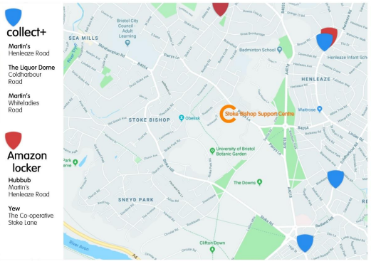
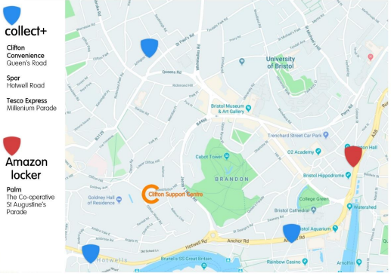

Third-Party Collections
If you are unable to collect your recorded mail yourself, you may arrange for someone to collect your recorded mail items on your behalf by following the below process:
For third-party collections in North & West Village:
- Forward your post notification email containing the bar code to the nominated third-party collector.
- It is your responsibility to arrange third party collections from Post Collect Point lockers, University of Bristol will not be held liable for facilitating these collections.
We reserve the right to withdraw third-party collections at busy periods. This is to fairly accommodate those that have made the trip to the Student Support Centre to collect their mail.

Restrictions
Our Facilities teams will not accept mail containing food/perishable items (including perishable medication which requires refrigeration), such as grocery deliveries or home cooking boxes, alcohol, or large/heavy items (as defined under section 6.1) or any prohibited items (listed under section 6.2). The restriction on perishable items does not include floral deliveries.

Size and Weight
No items will be accepted of weight greater than 20kg and of size greater than 50x50x50cm.
Items exceeding the size and/or weight restrictions or grocery deliveries (but not containing any prohibited items listed under section 6.2) may only be received directly by a Student. The student must provide their correct contact information and arrange to meet the courier directly. All responsibility for liaising with courier services rests with the Student and our Facilities teams will not provide any assistance.

Prohibited Items

Our Post Collection Points follow the guidance of Royal Mail, as a result mail containing the overleaf will be immediately rejected or confiscated and subsequently passed to University of Bristol Security Services and the Police.

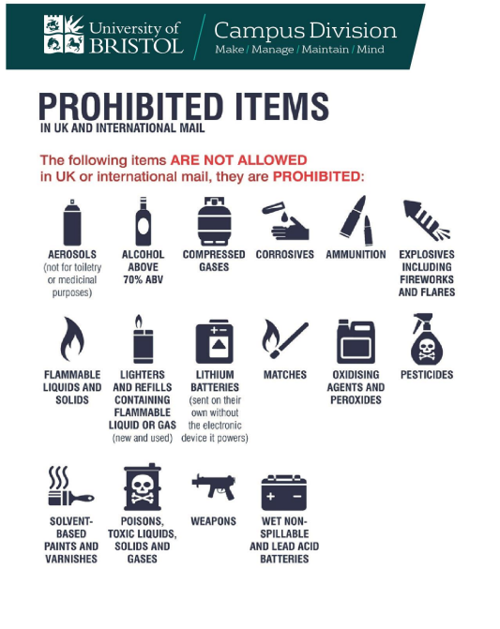
We would like to make it very clear that as we cannot carry prohibited items through our network, we will not accept any liability for any item that contains prohibited items. As the list of prohibited items can change from time to time, the list of prohibited items can be found here. The list quoted below was correct at the time of publication:

