(Name of social worker) had a meeting with their manager and solicitor because they are worried that your child/baby might not always be safe (when she is born).
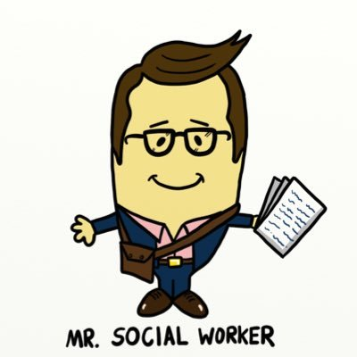

(put your photo here)
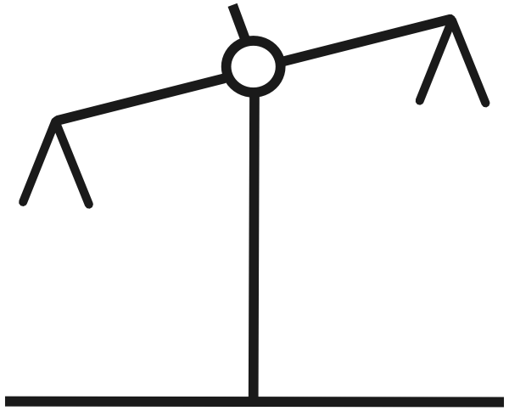
We talked about the things that make us more worried (risks) and the things that are going well (safety). These things balance out like scales but the risks were heavier than the safety.

Safety
Risks

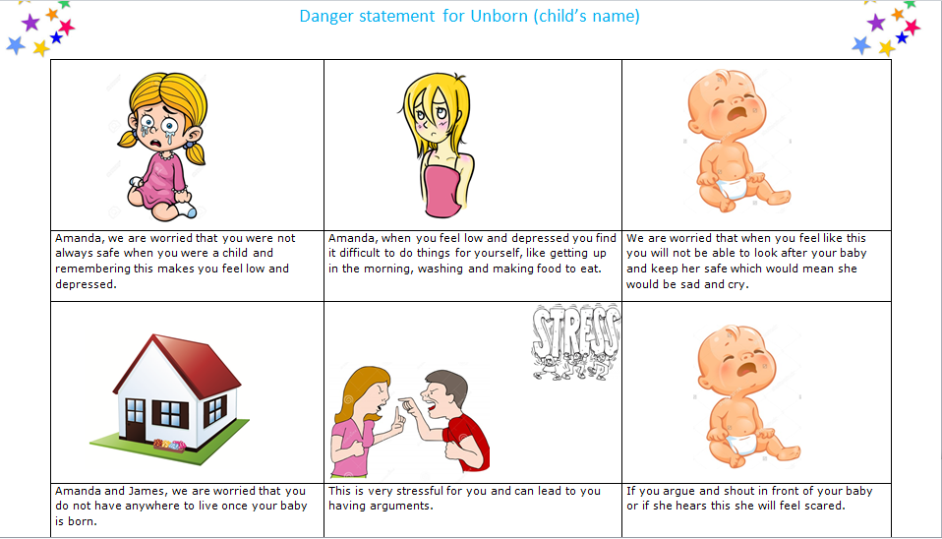
The risks that we are worried about are the things on your danger statement poster.

In our meeting we talked about how safe your child/baby is from 0 to 10:
When the safety goes up the number on the scale goes up and 10 means that your child/baby does not need a social worker because you can keep him/her safe with the help of your friends and family.
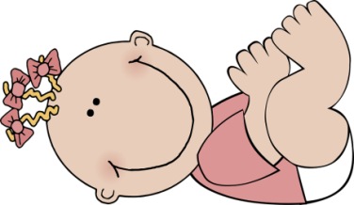

0 1 2 3 4 5 6 7 8 9 10

When the safety goes down the number on the scale goes down and 0 means we need to go to court to talk about how to keep your child/baby safe becasue we are worried that he /she is not safe at home.
0 1 2 3 4 5 6 7 8 9 10

At the moment the scale is…

We all want your child/baby to be safe and happy, like the safety goals on your poster.

We would like to have a meeting with you on Date, time, venue of MBP to talk about what you need to do to keep your baby safe so that we do not have to go to court and ask the judge this.

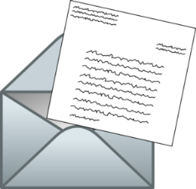
You need to find a solicitor so they can come to this meeting with you. Please take the long letter to the solicitor so they know when the meeting is. You will not have to pay for the solicitor if you take the long letter.

If you are not sure about anything you can call your social worker and ask them a question.

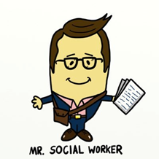

(put your photo here)

