Danger statement for (child’s name)
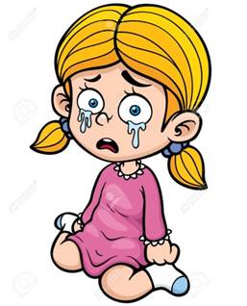 | 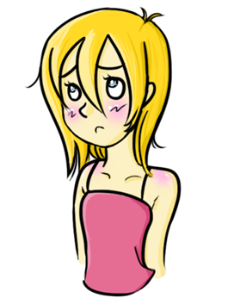
Amanda, we are worried that you were not always safe when you were a child and remembering this makes you feel low and depressed. | Amanda, when you feel low and depressed you find it difficult to do things for yourself, like getting up in the morning, washing and making food to eat. | We are worried that when you feel like this you will not be able to look after your baby and keep her safe which would mean she would be sad and cry.
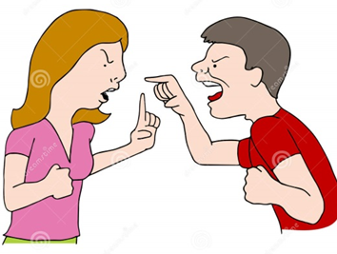

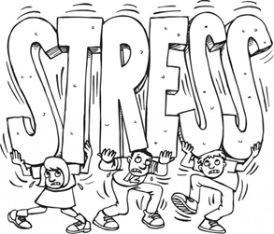
Amanda and James, we are worried that you do not have anywhere to live once your baby is born. | This is very stressful for you and can lead to you having arguments. | If you argue and shout in front of your baby or if she hears this she will feel scared.
James, sometimes you feel really stressed. | You use Cannabis because you say that it makes you feel calmer. | We are worried that if you use Cannabis you will not be able to look after your baby as well as when you are not using Cannabis and this could mean she gets hurt or is upset.

Safety goals for (child’s name)
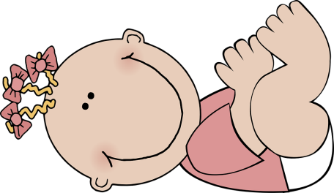  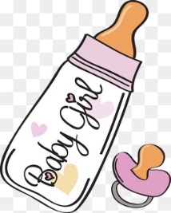 |  | 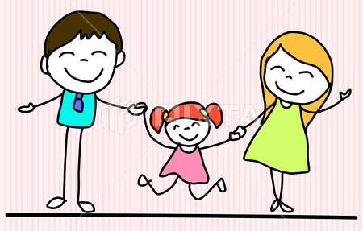
Baby feels safe because she is always looked after and has everything she needs. | Baby feels safe and warm because she has a home to live in. Amanda and James do not argue and shout and do not have to worry about being homeless. | Baby feels safe because she does not hear any arguing or shouting and James does not use Cannabis.

