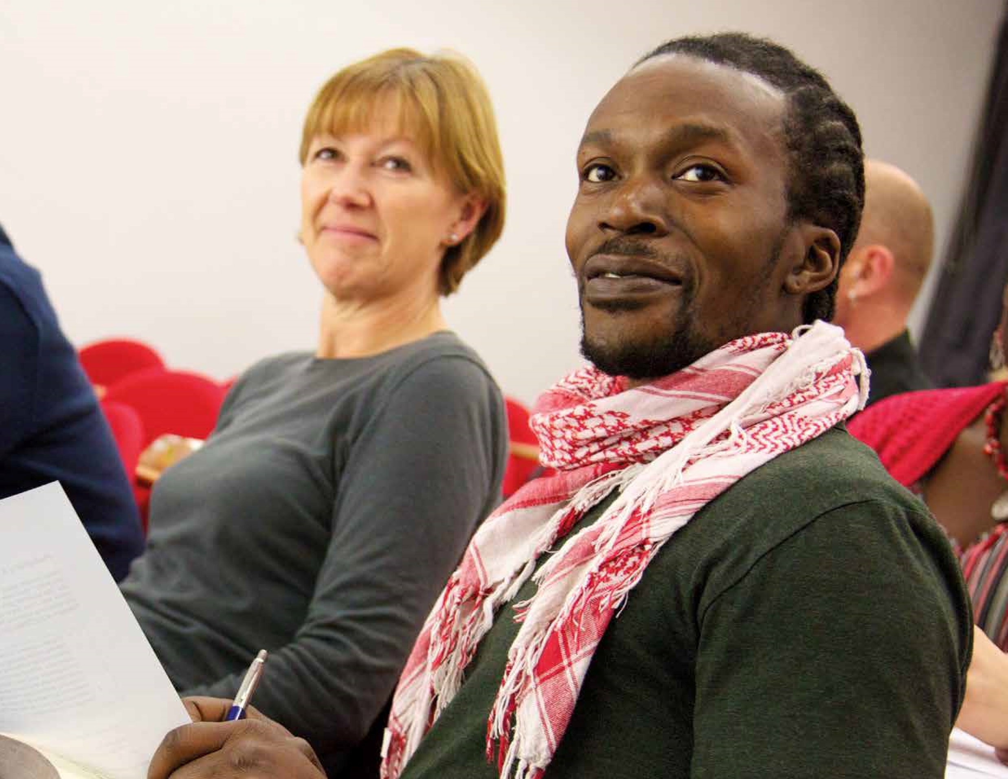

**E**

**W**

**Understanding**

**Society**

**Application form** for 2019/20

**A Pathway to Further Study**

## HOW TO APPLY

What Happens (and When)

Successful candidates will begin the course in **September 2019**



You will be invited to attend an interview

Send in your application form to [understanding-society@bristol.ac.uk](mailto:understanding-society@bristol.ac.uk)

More information and advice

You are advised to read the information in this pack carefully before completing your application form. We are very happy to help or to answer any questions you may have, so don’t hesitate to get in touch.

If you have any queries about the course, please email [understanding-society@bristol.ac.uk](mailto:understanding-society@bristol.ac.uk)

How and when to apply

Admission to the course is based upon your application form and an informal interview. The deadline for applications for the course is **Sunday 1 September 2019**. Interviews will be held in late August or early September.

Who can apply?

The course is open to all. It is designed primarily for mature students (over the age of 21) from the local area, who wish to return to further study, or younger students who may not have conventional prior qualifications.

You do not need to have any previous qualifications to apply and applications from those returning to study after a gap are encouraged. The most important thing is to explain in your personal statement (on the application form) why you would like to study on the course.

## ABOUT THE COURSE

Understanding Society is a short course, designed primarily to help mature students from the local area progress to further study, such as a degree in the School of Social Policy. The course is running for the third time from September 2019, but the University of Bristol runs similar courses in English (since 2007), History (since 2016) and Education (since 2018).

You do not need to have any prior qualifications to apply. The most important thing is to explain in your personal statement (on the application form) why you would like to study on the course. The course will be led by Em Morton, with contributions from a range of subject experts and advice and support on applying for further study at Bristol or elsewhere.

## What it’s all about?

**How does our society work?**

What issues do we face in today’s society? What works and what doesn’t? And what can we do about the things that don’t work? This is an interactive course, covering a wide range of topics, from social inequalities to democracy; from the justice system to protests; from the environment to what it really means to be part of society.

We'll draw on your experiences, along with journalism, social media, academic research, and a wide range of other sources to set the agenda for our debate and discussion. There will also be opportunities to develop your study skills – including note-taking, essay writing and taking part in discussion.

Dates for the course

**The course will run weekly (6pm to 8:45pm), from Tuesday 10 September 2019 to Tuesday 17 December 2019**.

**The classes will all be held at St Paul’s Learning Centre, 94 Grosvenor Road, Bristol, BS2 8XJ.**

What does the course aim to achieve?

Most of all, we want you to have an enjoyable experience of returning to study. It’s important to realise that this won’t be like school: we want you to have your own thoughts and opinions (and disagree with the tutor sometimes!) and there will be an emphasis on work completed in your own time, with support and advice provided during the class meetings. We hope you will go away from the course feeling excited about the topics discussed. You should also gain confidence for continuing your studies and a sense of the options that are open to you.

The course will encourage you to develop skills in:

**Reading and researching** a range of sources. We’ll be looking at lots of different types of sources which help shed light on our society.

**Discussion:** There will be an emphasis on class discussion and debate as well as on critical analysis of the sources. This is a great way to improve confidence and to start thinking about what you are reading. This leads towards…

**Writing:** There will be an emphasis in the opening weeks of the course on planning and writing essays and shorter assignments: so don’t panic if you haven’t written one before or if you are out of practice!

How is the course marked?

You will be awarded a mark for the course as a whole, which will be based on the marks for more than one assignment. You need 40% overall to pass the course.

## What happens after the course?

There are two possible routes into further study at the University of Bristol from this course:

1. If you feel confident about starting a degree straight away, you can apply for an [undergraduate degree](https://www.bristol.ac.uk/education/study/undergraduate/) in the School of Policy Studies. Please note that some degree programmes may require GCSE grades in relevant subject/s e.g. Maths.
2. If you feel like you need a bit more preparation before starting an undergraduate degree, you can apply for the **Foundation Year in Arts and Social Sciences**, a way into university for people without formal qualifications. Further information here: <http://www.bristol.ac.uk/arts/study/foundation/>

The course tutor and course director will advise you on your options, and support your application to any of these programmes. You can find out more about mature students at Bristol University here: <http://www.bristol.ac.uk/study/mature/>

Course fee

The course fee for Understanding Society is **£350**.

We have a number of **bursaries** available to help students who may be unable to pay the course fee in full. If you apply for a bursary, you will be asked to complete a short form which will be assessed by the Student Funding Office.

Please note that you must arrange payment before beginning the course.

**Frequently asked questions**

We have put the answers to some frequently asked questions below. If you have a question that is not covered here, then please get in touch. We will be happy to help, or to discuss any concerns you have.

**What happens after I apply?**

We will send you an acknowledgement of your application form within 21 days of receiving it. We will then write to invite you for a short informal interview in late August or early September 2019.

**What will I be asked at interview?**

One aim of the interview is to give you a detailed picture of the course, and of the routes to further study that it provides. So, the interview is partly an opportunity for you to ask questions about the course and about returning to study. We will ask you about: your reasons for wanting to study on the course; what you interests you about studying society and how it works; how the course would fit in with your other commitments; your aims and ambitions after you finish the course.

**I don’t have A-Levels (or) I don’t have a relevant GCSE (or) I didn’t do well at school… can I apply?**

**Yes!** You do not need to have any previous qualifications to apply for the course, as long as you can demonstrate that you are motivated and enthusiastic, that you enjoy learning, and that you are committed to the idea of studying at a higher level.

**How do you decide who gets a place on the course?**

Admission to the course is not based on previous achievements or qualifications. We are looking for students who are motivated, enthusiastic and committed; who have strong reasons for wanting to return to studying; and who can demonstrate that they will be able to manage the demands of study at this level. We hope to accommodate as many students as we can on the course, though it may not be possible to give a place to everyone who applies.

**What if I am not offered a place?**

Anyone who is not offered a place will be encouraged to talk through other options.

**Will I automatically be offered a place on a degree afterwards?**

No, you will need to apply for a place. You will be given lots of information on the options for continuing your studies as part of the course.

**What if I’m not sure I want to continue at the end?**

The Changing Education course should be useful and enjoyable in itself. If you decide not to apply for a degree at the end, we hope you will have gained important skills and confidence. Often evidence of further study at this level can be useful in career progression or in taking on work in the community.

**How can I fit my studies around work and/or family?**

The course itself is taught one evening per week, on 14 evenings over six months. This format is designed to make it accessible to a wide range of students. On top of this, we would normally expect you to complete a couple of hours of work in your own time per week. There will be advice during the course on managing your studies, and you will be with a group of mature students who are faced with similar pressures on their time – the group atmosphere can be useful in adjusting to the academic demands of the course.

|  |
| --- |
| **Please attach a passport-sized**    **photograph**  **HERE / to email as attachment** |



**Understanding Society:**

**A Pathway to Further Study**

Application Form

Please complete this form in **BLOCK CAPITAL LETTERS** and in **black ink**. You must attach a passport-sized photograph to the top of this form.

#### Personal Details

TITLE: ________ FORENAMES: _______________________________________________

SURNAME: _________________________________________________________________

ADDRESS AND POSTCODE (for all correspondence):

__________________________________________________________________________

__________________________________________________________________________

E-MAIL ADDRESS: __________________________________________________________

HOME PHONE NUMBER: _____________________________________________________

DAYTIME PHONE NUMBER: __________________________________________________

DATE OF BIRTH: ____________________________________________________________

EDUCATIONAL AND PROFESSIONAL QUALIFICATIONS (please indicate the award, the institution and the date. Please indicate clearly any University of Bristol awards):

__________________________________________________________________________

__________________________________________________________________________

Do you have any unspent criminal convictions? Yes □ No □

If ‘yes’ please send separate details, marked ‘Strictly Confidential’, to Richard Pettigrew c/o Department of Philosophy, University of Bristol, Cotham House, Bristol, BS6 6JL.

Do you have access or support requirements (i.e. level access, induction loop, interpreter, information in large print or alternative formats)? Yes  No 

If yes, please give details of any support required on a separate sheet, and we will contact you to discuss your requirements.

#### Personal Statement

Please comment on the next page, **in no more than 500 words**, on your reasons for wishing to study on the Changing Education course. You may use the space provided or attach an additional sheet if you prefer.

In your personal statement, you may wish to comment on: your interest in studying society (books you have enjoyed, or films or newspaper articles; particular questions that interest you); your experiences of study in the past (whether positive or negative); your reasons for wanting to return to study now; what you would like to achieve by the end of the course; whether you would like to go on to study for a degree in Education or other further study; your other hobbies and interests.

**Personal Statement**

|  |
| --- |
|  |

#### University of Bristol introductions

This section of the form is entirely optional. It will not prejudice your application if you do not complete it. We use the information in this section to monitor participation on our courses. It would be helpful to us if you were able to provide this information.

NATIONALITY: ___________________________________________

How would you describe yourself? (Please tick the box that best applies to you)

|  |  |
| --- | --- |
| (1) White - British | (11) Other Asian background |
| (2) White - Irish | (12) Mixed - White and Black Caribbean |
| (3) Other White background | (13) Mixed - White and Black African |
| (4) Black or Black British - Caribbean | (14) Mixed - White and Asian Indian |
| (5) Black or Black British - African | (15) Mixed - White and Asian Pakistani |
| (6) Other Black Background | (16) Mixed - White and Asian Bangladeshi |
| (7) Asian or Asian British - Indian | (17) Other Mixed background |
| (8) Asian or Asian British - Pakistani | (18) Other Ethnic background |
| (9) Asian or Asian British - Bangladeshi | (19) Not known |
| (10) Chinese or other Ethnic background - Chinese | (20) Prefer not to say |

Are you disabled? Yes □ No □

If you answered yes, how would you describe your disability? (please tick one only).

1) Dyslexia □ 2) Sight impairment □

3) Hearing impairment □ 4) Mobility difficulties □

1. Personal care support □
2. Unseen disability (eg diabetes, asthma, epilepsy) □
3. Mobility difficulties □ 8) Multiple disabilities □

9) Other (please specify) .......................................................................................

#### Declaration

I confirm that the information given on this form is true, complete and accurate, and that no information requested, or other material information has been omitted. I consent to the processing of my data by the University of Bristol for the purpose of dealing with this application.

Applicant’s signature: Date: ________________________

All decisions by the University are taken in good faith on the basis of statements made on your application form. If the University discovers that you have made a false statement or have omitted significant information from your application form, for example regarding examination results, it may withdraw or amend its offer, or terminate your registration, according to circumstances.

When completed, please return this form to: [**understanding**](mailto:understanding)**-society@bristol.ac.uk or post it to Richard Pettigrew c/o Department of Philosophy, University of Bristol, Cotham House, Bristol, BS6 6JL**

**Before you send!**

Have you:

…included a photo? (passport style)

…completed your personal statement?

…signed your form?

Data protection statement

The data collected here will be processed by the University of Bristol in accordance with the Data Protection Act 2018 and the General Data Protection Regulation. It will be kept in a secure database for as long as we need in order to track your progress through higher education. It will be used by the University to administer participation in the scheme and for consideration of your application to the University, as well as to conduct database analysis and quality assurance checks.

For research, monitoring and evaluation purposes only, your data may be shared with appropriate third-party organisations such as the Higher Education Funding Council for England (HEFCE), Higher Education Statistics Agency (HESA), UCAS, and the Office for Students, and with our partners including Higher Education Access Tracker (HEAT) service and its members. Collectively this allows the central HEAT service to track students’ progression into Higher Education and beyond. Enabling us to evaluate the effectiveness of the scheme and analyse the combinations of activities that show most impact on enrolment and success rates in higher education. Thus, contributing to the government policy to widen participation in higher education. The University and its partners will not use your data in a way that would affect you individually, and we will not release data to anyone who is unauthorised. Sharing this data is permissible under the university's public task. Should you wish to opt out of sharing your data, please contact [heat-database@bristol.ac.uk](mailto:heat-database@bristol.ac.uk)

Under the Data Protection Act 2018 and the General Data Protection Regulation you have the right to request a copy of the information that we hold about you. You may also ask us to correct or remove any information you think is inaccurate, or opt out of sharing your data at any time. If you wish to do this, please contact heat-database@bristol.ac.uk. Please visit www.bristol.ac.uk/privacy for more information on how the University uses your personal data.