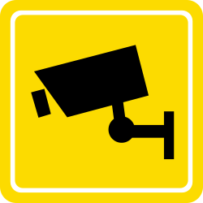

UNIVERSITY OF BRISTOL
CCTV IMPACT ASSESSMENT FORM

This form should be completed by staff requesting to install ad-hoc CCTV cameras, for example for use in teaching or research. This does not apply to cameras on the Security Services network.

Name of applicant:
Date:
Position within the University:
Proposed location for camera(s):

For what purpose(s) will the CCTV be used?
What are the problems it is intended to address?
What are the benefits to be gained from its use?
Can less privacy-intrusive solutions (e.g. improved lighting) achieve the same objectives?
Do you need images of identifiable individuals, or could the scheme use other images not capable of identifying individuals?
Will the particular equipment/system being considered deliver the desired benefits now and remain suitable in the future?
What (if any) future demands may arise for wider use of the images and how will you address these?
What are the views of those individuals (if any) who will be under surveillance?
What could you do to minimise intrusion for those that may be monitored, particularly if specific concerns have been expressed?
Is appropriate signage informing individuals of the camera in place (if required)?
Proposed time period for installation of the CCTV

This Section to be completed by the Secretary’s Office
Is the proposed system in accordance with the law? (Primarily the Data Protection Act and Human Rights Act)
Is it necessary to address a pressing need, such as public safety or crime prevention?
Is it justified in the circumstances?
Is it proportionate to the problem that it is designed to deal with?
Approved by Director of Legal Services / Deputy Secretary

Date

