Grammarly
Grammarly is an online/downloadable program which helps to improve your writing. This includes explaining why areas of your writing need working on.
Grammarly can be accessed through internet browser Sign Up – Create a Free Account | Grammarly – when setting up this will need to be linked to an email account.
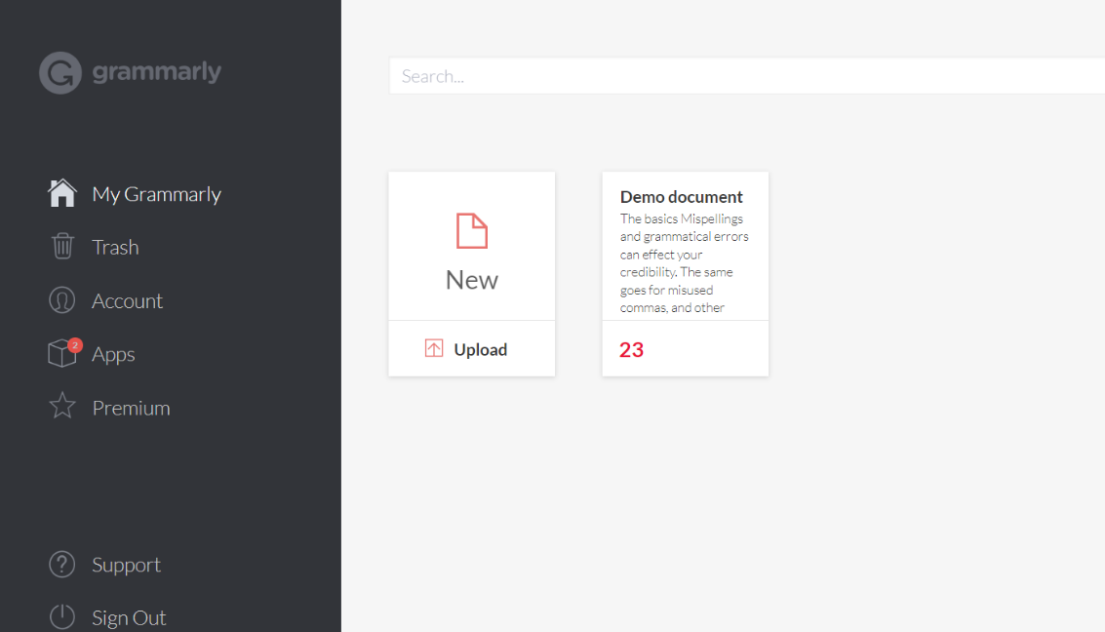
The free account enables you to upload documents that you are working on to get insight into how to improve it and also to learn to be able to improve your writing for the future.

If you would like the use of Grammarly during the use of other programs, for example email, then it can be downloaded by going to the App section and choosing where you what platforms you would like to have access to it. The below shows that access has been set up to access it on a Window Desktop but also through the Chrome browser.
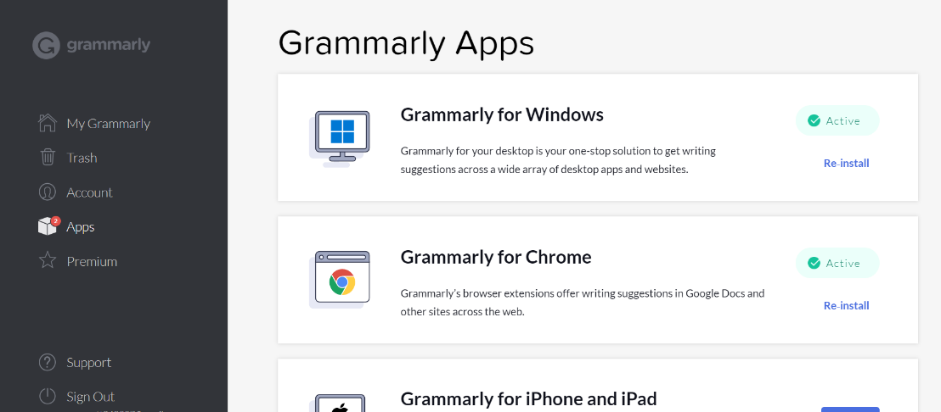
.
Grammarly then shows up as a small bubble icon and can be dragged around the screen.
More information on how to use Grammarly can be found on the Editor User Guide Web page.

Please note currently Grammarly does not work with screen readers such as Jaws or NVDA.

