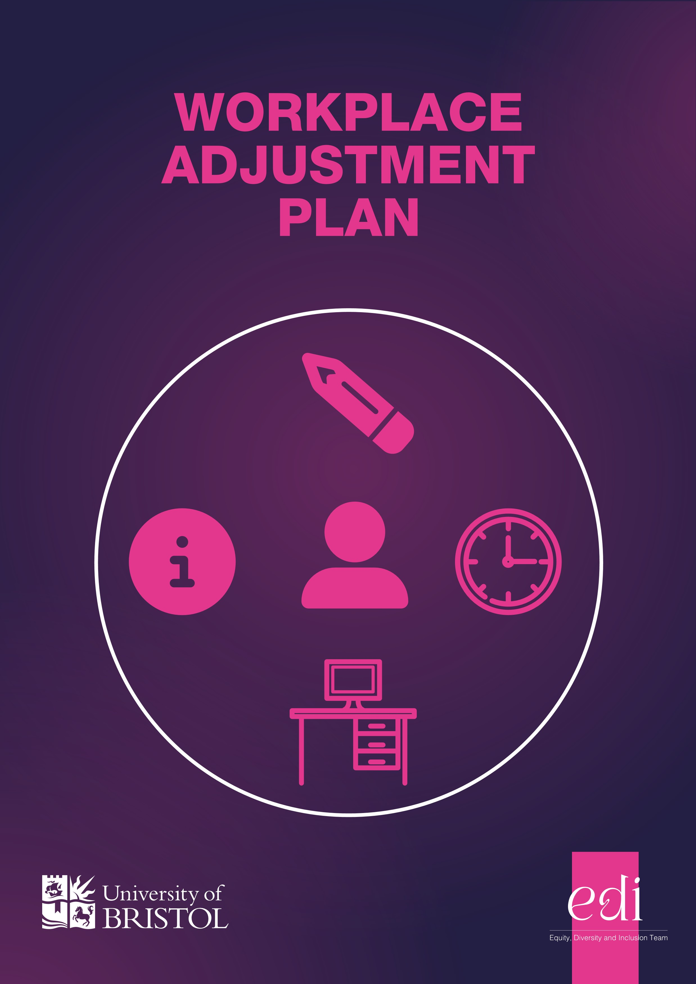
The Workplace Adjustment Plan (‘the Plan’) is a living record of adjustments agreed between you and your line manager. It provides a framework within which to discuss, agree and review any support that may be required at work. For example, this could be:

- A different start and finish time
- Ways of communicating at work
- More regular breaks at work
- A specific seat at your desk
Workplace Adjustment Plan
- Modifications to your desk
- Any appointments you regularly need to attend to stay well at work

Please complete Section 1 of the Plan before sharing and discussing this with your line manager. Agreed adjustments and subsequent reviews can be recorded in Section 2.
The individual who owns the Plan:

Things to know about how my health condition or disability impacts me at work
For example:
•
any tasks you need help with or cannot do easily
•
any tasks which may take longer for you to carry out
•
any diagnosis you feel would be helpful for your manager to know
•
any information regarding medication or interventions that you feel are relevant to work - these
could be fluctuations in conditions or symptoms you would like your line manager to be aware of
Section 1: About me

Things that support me at work
Include any information about support you require at work, either all the time or as conditions fluctuate.
It might be helpful to refer to any recommendations from other sources, such as the
University

Occupational Health Servic
e

or
Access to Wor
k

as well as any support you had when you were
in education or a previous job. Don’t worry if you are not sure what could support you, as you can
discuss this further with your line manager and come up with ideas together.
Time

Are there times of the day when your disability/health condition impacts you differently?

Work environment

What sort of work environment suits you?

Technology and equipment

What specialist technology and equipment helps you at work?
Communicating at work

How do you like to be communicated with in the office and given tasks?

For example, you may like to be emailed your work tasks to help you remember or prioritise.

Additional information
Use this space to share any information not covered in the previous sections.

Discuss the information provided in Section 1 with your line manager and record agreed adjustments
here. This Section should be developed within the context of university guidance on reasonable
adjustments (
access her
e
)
, with specialist advice from your HR Business Partnering Team if required.

The following workplace adjustments were agreed between me and my line manager:
Date adjustments were agreed:
Section 2: Agreed adjustments
Will details of the adjustments need to be shared with others?
Yes ☐
No ☐
If yes, please provide further details of how you have agreed to share this:

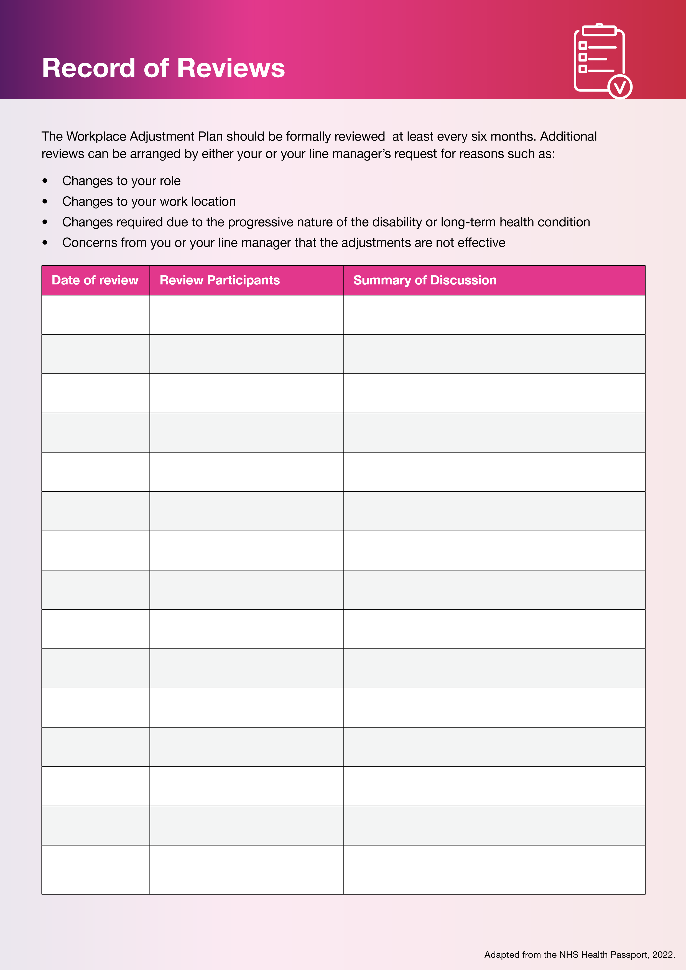
t

bristol.ac.uk/inclusion/disability

