ASSESSING EQUALITY IMPACT
Guidance for staff

LEARN

ACT MEASURE

ASSESSING EQUALITY IMPACT

Introduction

The University of Bristol has made firm commitments to support equality, diversity and inclusion in our University Strategy and we aspire to be recognised as a sector leader in our approach to deliver this key priority. We want to create an inclusive work and study environment where people feel welcomed, valued, and supported.
Removing any existing and potential barriers to inclusion is critical to the realisation of this aim.
The central staff EDI Team has developed this guidance and the supporting LEARN - ACT - MEASURE model to ensure that our colleagues are equipped to fully embed an assessment of equality impact into any decisions, policies or activities that may impact on people thus ensuring that these are inclusive by design.

CONTENTS

- What is an assessment of equality impact? 4
- Why should we do this? 5
- When should equality impact be considered? 6
- Who is responsible? 6
- Assessing equality impact: Learn - Act - Measure 7
LEARN 8
ACT 9
MEASURE 10
Annex: due regard and assessing the impact of equality 11

WHAT IS AN ASSESSMENT OF EQUALITY IMPACT?
An assessment of equality impact – or equality impact assessment (EIA) - is an evidence- based analysis of key decisions, policies, procedures and activities to determine any differential or adverse impact on diverse groups of people, helping to ensure that they are fair and do not discriminate. For the purposes of this guidance, the term ‘policy’ is used as shorthand for the range of areas that should be assessed for equality impact. As well as any relevant policy, this includes anything that impacts on people: students, staff, and the wider community, such as:

- Strategies
- Policies
- Organisational change
- Processes
- Plans
- Codes of practice
- Procedures

- Projects
- Programmes
- Systems
- Service delivery
- Events
- Activities

An EIA involves the analysis of data, information and feedback from staff and/or students to help us to understand the actual, or potential, impact of our policies and practices when assessed against the nine protected characteristics:

- Age
- Disability
- Gender reassignment
- Marriage & civil partnership
- Pregnancy & maternity
- Race
- Religion or belief
- Sex
- Sexual orientation

Our approach also provides an opportunity to consider other factors relevant to inclusion, such as caring responsibilities, part-time working and socio-economic background.

At the University of Bristol, we do not see EIA as a separate or stand-alone process, but rather we aim to integrate considerations of equality impact into our key decision- making processes.

WHY SHOULD WE DO THIS?
As a public body, we have a legal responsibility to demonstrate that we are taking action to promote equality in relation to policy making, the delivery of services and employment. EIA is a tool that helps us to proactively meet the requirements of the Public Sector Equality Duty under the Equality Act 2010 that require us to have due regard to:

  - Eliminate unlawful discrimination, harassment and victimisation and other conduct, in line with the Equality Act 2010
  - Advance equality of opportunity between people who share a protected characteristic and those who do not
  - Foster good relations between people who share a protected characteristic and those who do not

This means that consideration of equality must influence our decisions, such as how we operate as an employer and education provider; how we develop, evaluate and review policy; how we design, deliver and evaluate our services, and how we commission and procure from others. This requires each of us to be deliberate and intentional about understanding how our decisions will impact on different groups of people across our university.

When we design or make changes to how we do things or what we provide, it may seem that by ensuring that they apply equally to everyone they will be fair. However, we can sometimes make decisions or create policies or processes that have unintended consequences for certain groups. With closer consideration and analysis, we may find that a particular group might be impacted more than others, put at a disadvantage, or unable to access or benefit equally from it. By embedding EIA in our planning and decision-making, we can pre-empt issues by anticipating impact at early stages, identifying potential discrimination and removing it, taking action to promote equality instead. This approach ultimately supports the University in demonstrating ‘due regard’ to the aims of the equality duty.

Our approach to EIA is informed by principles established through case law that are relevant for a public body in demonstrating ‘due regard’ under the equality duty. These principles are provided in the annex.

Compliance with the general equality duty is a legal obligation, but it also supports our strategic aim to sustain an inclusive work and study environment for everyone, regardless of background or circumstance. Removing any existing and potential barriers to inclusion is critical to realising this aim.

WHEN SHOULD EQUALITY IMPACT BE CONSIDERED?
Equality impact should be considered at the early stages of development or planning something new; when we are reviewing an existing policy or service; or when we are removing an existing policy or service. This allows time for changes to be made, where possible and
to mitigate any negative equality impact. Rather than being seen as a stand-alone separate exercise, EIA should be embedded into your usual processes so that it becomes ‘business as usual’ and an integral part of decision-making. Alongside any considerations of budgetary or resource implications at the early stages of development, colleagues are expected to also consider any implications for equality (positive and negative) to ensure that we understand
how our policies and decisions can affect people in different ways. For example, recording and sharing lectures benefits all students, but failing to consider how students who might be sight or hearing impaired might access these recordings illustrates how a well-intended policy can have unintended and exclusionary consequences.

EIA is for planning and more strategic decision-making. It is not for making decisions on an individual basis. For example, we would not use EIA to decide if a recruitment/selection policy was discriminating against one person, but we would use it to design an inclusive recruitment/selection policy from the outset, or to review and update an existing policy.

WHO IS RESPONSIBLE?
The owner of the policy (who has authority to make changes) is responsible for ensuring that they have complied with the equality duty by consciously thinking about the three aims cited in section 2 above, as part of the process of decision-making. They should have a good understanding of the policy and an awareness of the people it could affect. The implications should be presented alongside the proposals for approval, so that a decision can be made with a breadth of knowledge of any equality impacts.

The Dean/Divisional Head who holds responsibility for the policy/service is ultimately accountable for ensuring that equality impact is considered and that due regard for the aims of the equality duty can be evidenced.

Project/Programme Managers are responsible for ensuring that EIA is embedded at each stage of development via the relevant Project/Programme Board, in particular at project initiation via the Business Case document.

Chairs and Secretaries of University Committees act as ‘gatekeepers’, ensuring that equality impact is summarised on committee paper cover sheets. We have also developed an Equality Impact Assessment Form that can be submitted alongside the cover sheet to demonstrate compliance and inform discussion.

The central Equity, Diversity & Inclusion Team can provide advice and guidance on how to complete this assessment effectively, but they are not responsible for undertaking the EIA.

ASSESSING EQUALITY IMPACT: LEARN-ACT-MEASURE
We have developed a simple three-step model LEARN - ACT - MEASURE to support colleagues in integrating EIA into their activity and to ensure that the University can demonstrate due regard to the aims of the equality duty.

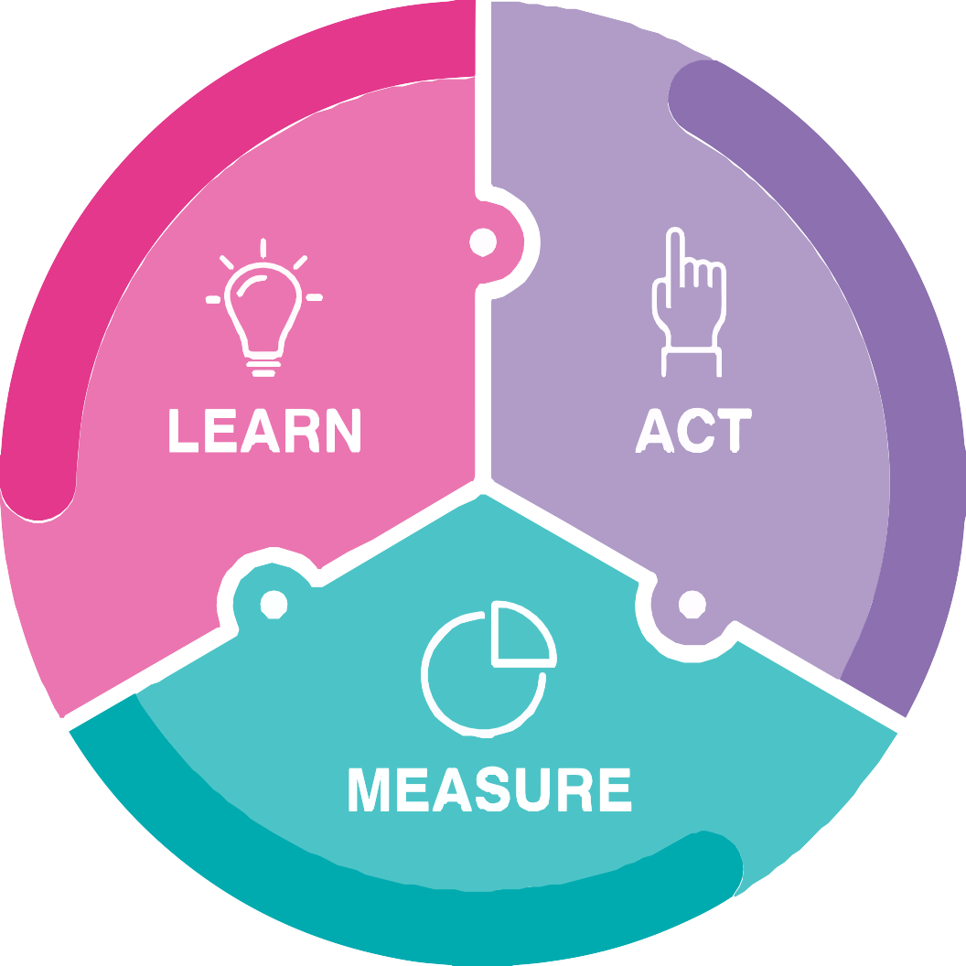

We want to position consideration of equality impact as a natural part of decision-making, moving beyond a ‘tick box’ approach. The LEARN - ACT - MEASURE model will help to ensure that our decisions, policies or activities are inclusive by design.

LEARN

The focus at the LEARN stage is on building/reviewing your evidence base to develop your understanding of the people that make up our university, for example demographic data on the diversity of our students and staff. Information sources could include:

  - Student data reports
  - Staff data reports, which may be requested by emailing Finance HR.
  - Annual EDI Reports
  - Results of Staff or Student surveys
  - Participation/usage rates data by different groups
  - Relevant committees/working groups, particularly those with a remit for EDI
  - Pay Gap reports
  - Findings of external research/reports
  - Feedback and anecdotal evidence
  - Evidence from any previous engagement/consultation
  - Local census data

This will help you to better understand the different groups of people who may be impacted by your policy. Further engagement and consultation can then be undertaken to inform your understanding of how these groups might be impacted and to develop an overview of the needs of these different groups so that they can be considered and met where possible. This evidence can then be used to inform and shape your policy.

9

ACT

The ACT stage requires you to act upon the findings of the LEARN stage and undertake an evidence-based evaluation of both the positive and negative equality impacts that the policy has, or is likely to have, in relation to each of the protected characteristics.

University policy is subject to consideration and approval at relevant committees/working groups, and this is how the ACT stage is implemented, as the evidence gathered at the LEARN stage is considered as the policy develops. The policy owner will reflect the findings of any assessment of equality impact on committee paper cover sheets, attaching a completed EIA form where relevant. Integrating EIA with any committee-based consultation and ensuring that discussion and decisions are documented as appropriate will evidence compliance with the aims of the equality duty.

Both positive and negative impacts should be discussed and documented. Where negative equality impact is identified, it is possible to proceed with the policy provided that it can be ‘objectively justified’ as a proportionate means of achieving a legitimate aim: for example, there may be no reasonable alternative to achieve the aims of the policy, or it may be critical to business efficiency. EIA does not mean that you cannot make decisions that might adversely impact on people, it simply means that we must be mindful of how our decisions might impact on different groups of people and take steps to mitigate this impact where we can.

Being intentional and deliberate in our efforts to sustain an inclusive university is vital to the success of our University Strategy: focused and documented discussions on equality impact will underpin this. Considering equality impact after a decision has been reached will not achieve compliance with the equality duty.

bristol.ac.uk/inclusion

MEASURE

Once you have used your collective knowledge and understanding to implement your decision, you then need to consider how you will continue to MEASURE the ongoing impact going forward.

For example, if you have introduced a new wellbeing service that is intended to be inclusive of a range of users, you will need to monitor the diversity of users accessing that service
to understand if you are reaching a broad range of people. If your data shows that you are missing groups of people, it is helpful to return to the LEARN stage to better understand why those groups are not accessing the service. You might then ACT by reviewing the service and removing any unintentional barriers to access, then you continue to MEASURE the impact of the newly implemented changes intended to improve access going forward.

In this way, equality impact becomes an ongoing area of assessment broadening our understanding of the different needs of our staff, students, and other stakeholders and how these can be met.

This guidance has been informed by: Public Sector Equality Duty | Equality and Human Rights Commission (equalityhumanrights.com)

equality-analysis-guidance.pdf (ncl.ac.uk)

11

ANNEX: DUE REGARD AND ASSESSING THE IMPACT OF EQUALITY
Case law known as the ‘Brown Principles’1 sets out a broad indication of what public sector organisations need to do to in respect of to the aims set out in the general equality duties. While indicating how courts interpret the duties, they are not additional legal requirements.

The following are some key parts of the Brown Principles:

- Decision-makers must be made aware of their duty to have ‘due regard’ to the aims of the duty.
- ‘Due regard’ involved a conscious approach. Attempts to justify a decision as being consistent with the exercise of the duty, when it was not considered before the decision are not enough to discharge the duty. General regard to the issue of equality is not enough to comply with the duty.
- The duty must be exercised in substance, with rigour, and with an open mind in such a way as it influences the final decision.
- The duty has to be integrated …
it is not a question of ‘ticking boxes’.
- The duty cannot be delegated.
- It is good practice for those exercising public functions to keep an accurate record showing that they had actually considered the general equality duty and pondered relevant questions. If records are not kept it may make it more difficult, evidentially,
for a public authority to persuade a court that it has fulfilled the duty.

In 2013, the Court of Appeal confirmed some additional principles2:

- The equality duty is an integral and important part of the mechanisms for ensuring the fulfilment of the aims of anti-discrimination legislation.
- The duty is upon the decision maker personally. What matters is what [they] took into account and what [they] knew.
- A public body must assess the risk and extent of any adverse impact and the ways in which such risk may be eliminated before the adoption of a proposed policy.
- A public body must have available enough evidence to demonstrate that it has discharged the duty.
- Public bodies should place considerations of equality, where they arise, at the centre of formulation of policy, side by side with all other pressing circumstances of whatever magnitude.

1 R (Brown) v Secretary of State for Work & Pensions [2008] EWHC 3158 (Admin) This case was an application for judicial review to the Divisional Court. The subject of the challenge was a proposed programme of Post Office closures and an alleged failure to carry out a disability equality impact assessment. It also alleged a failure to have due regard to the need to promote equality of opportunity between people who are disabled and those who are not disabled when making his final decision regarding the Post Office closure programme. The challenge was unsuccessful, but resulted in the Court setting out what are known as ‘the Brown principles’.

2 Stuart Bracking and others v Secretary of State for Work and Pensions (Equality and Human Rights Commission intervening) [2013] EWCA Civ 1345 In this case, the Court of Appeal overturned the government’s decision to close the Independent Living Fund (ILF), a discretionary trust funded by the Department for Work and Pensions (DWP) that supports care packages to help disabled people live independent lives. The court found that the decision to close the ILF had been taken without complying with the public sector equality duty (PSED).

bristol.ac.uk/inclusion

If you need all or part of this publication in an alternative format please contact the Equity, Diversity and Inclusion Team:

Email edi-team@bristol.ac.uk

bristol.ac.uk/inclusion

