EQUALITY IMPACT ASSESSMENT
CHECKLIST

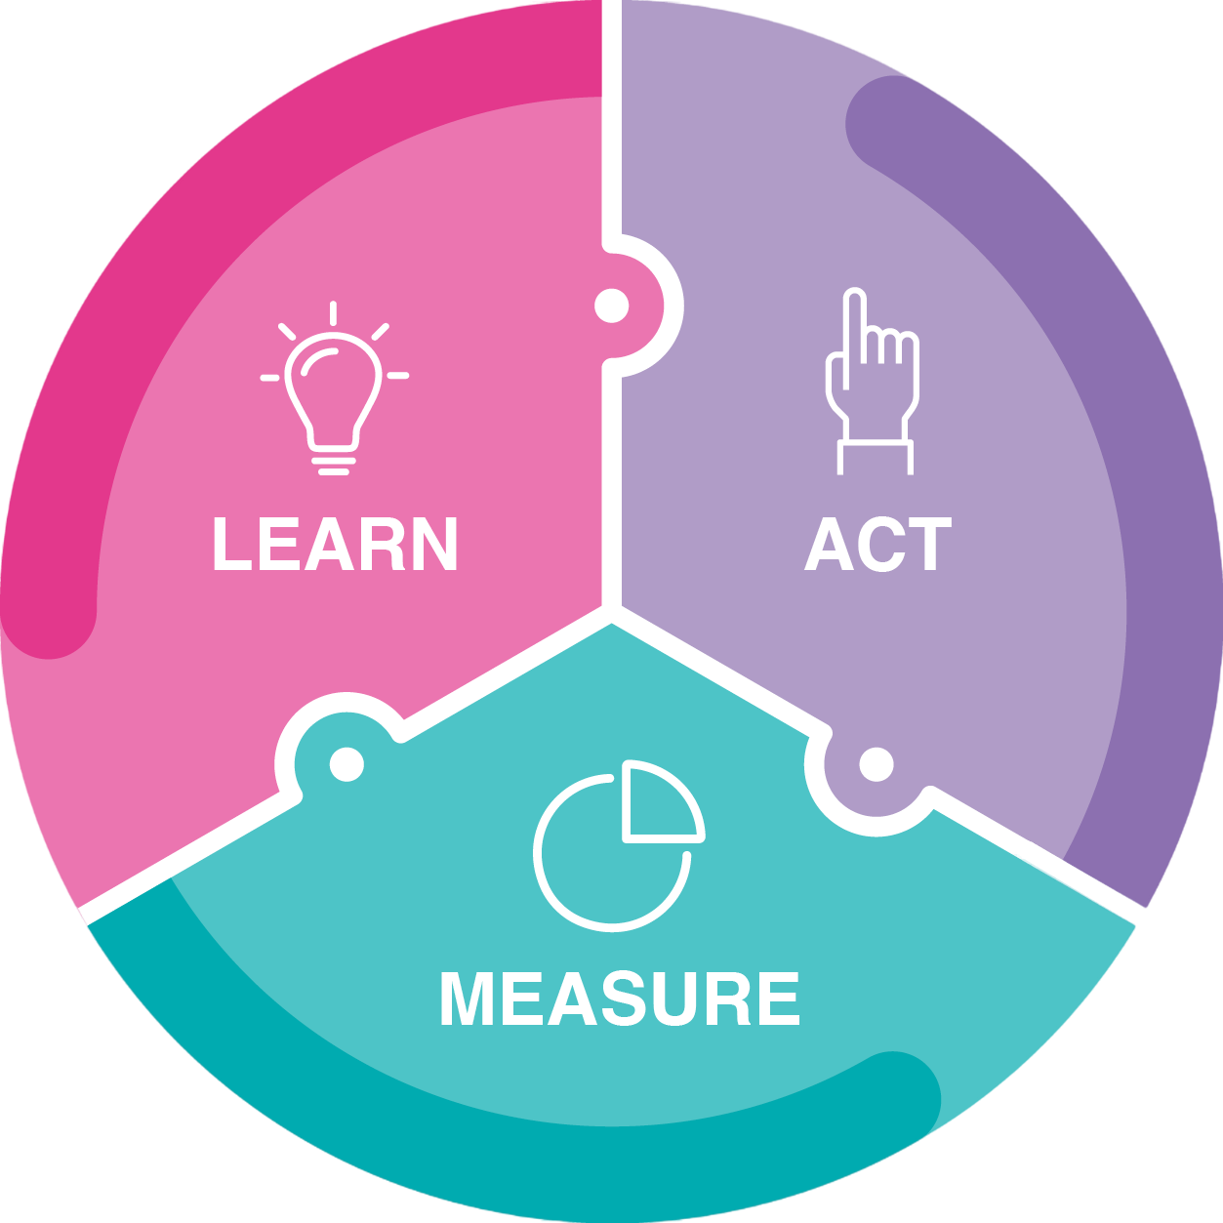
LEARN
Build and review evidence to develop understanding about different people who might be affected by the policy.
☐ Access a range of information which is sufficient to analyse the impact
☐ Diverse options and opinions have been considered, consulting if required
☐ An overview of the needs of different groups has been established

ACT
Use evidence to evaluate equality impact, promoting equality and mitigating adverse impact where possible.
☐ Any impact on different groups has been discussed and documented
☐ Proposed actions promote equality and reduce adverse impact if possible
☐ An outcome/decision has been reached and justified where required

MEASURE
Continually review and invite feedback to understand impact once implemented.
☐ Mechanisms are in place to ensure outcomes are monitored
☐ There is a clear process for gathering feedback from those affected by the policy
☐ The Learn-Act-Measure process is applied when the policy is reviewed or updated

LEARN - ACT - MEASURE
EQUALITY IMPACT ASSESSMENT FORM

Name of the policy and overview of its aims:

Summary of consultation and evidence, including committees where the equality impact was discussed:

Impact on different groups of staff and students
Protected characteristic | Potential impact and action to mitigate adverse impact and/or advance equality of opportunity¹
Age
Disability
Gender Reassignment
Marriage and Civil Partnership
Pregnancy and Maternity
Race
Religion or Belief
Sex
Sexual Orientation
Additional areas you may wish to consider:
Parents/Carers
Part-time staff/students
Socio-economic background
Intersectionality (any relevant information relating to the intersection of any of these protected groups)

Monitoring and Review
How will you measure the ongoing impact of the policy/decision/service?

Owner of Policy (name and job title):
Sign off from Dean/Divisional Head (name and job title):
Date:

¹ Both positive and negative impacts should be discussed and documented. Where negative equality impact is identified, it is possible to
proceed with the policy provided that it can be ‘objectively justified’ as a proportionate means of achieving a legitimate aim: for example, there may be no reasonable alternative to achieve the aims of the policy or it may be critical to business efficiency. EIA does not mean that you cannot make decisions that might adversely impact on people, it simply means that we must be mindful of how our decisions might impact on different groups of people and take steps to mitigate this impact where we can. For example, if we were to close a programme, we might propose that we ‘teach out’ the existing student cohort so that they can complete their studies.

