ANNUAL DIVERSITY MONITORING REPORT 2022-23

Our mission is to make a positive impact locally, nationally, and globally by addressing society’s greatest challenges through our distinctive education, innovative research and the value we place on excellence, inclusivity and partnership. Diversity is an essential component to driving innovation: different perspectives, experiences and ideas are critical to our ability to remain curious and creative, thus maintaining our position as a leading research-intensive university.

The University’s Annual Diversity Monitoring Report informs our people-led approach to equity and inclusion and we strive to ensure our staff and student populations reflect and are representative of society as a whole. This Report accompanies the University’s Equality, Diversity and Inclusion Annual Report for the period 2022–2023.

ANNUAL DIVERSITY MONITORING REPORT 2022-23

STUDENTS

Demographic data is collected through a combination of application and student registration processes. Sector comparisons are taken from HESA Who’s studying in HE? data reports (https://www.hesa.ac.uk/data-and-analysis/students/whos-in-he).

Student numbers
Level of study | Undergraduate | Postgraduate Taught | Postgraduate Research | Total
2020/21 | 23,185 | 9,098 | 4,174 | 36,386
2021/22 | 24,730 | 9,467 | 4,324 | 38,433
2022/23 | 25,249 | 10,025 | 4,212 | 39,413

Age
Age on entry | Under 21 | 21-25 | 26-30 | 31-40 | 41-50 | 51 and over | Unknown
2020/21 | 68.8% | 20.9% | 5.2% | 3.5% | 1.1% | 0.6% | 0.0%
2021/22 | 69.6% | 20.9% | 4.9% | 3.2% | 1.0% | 0.5% | 0.0%
2022/23 | 69.5% | 20.4% | 5.0% | 3.5% | 1.1% | 0.6% | 0.0%

Age on entry by level of study
UG students | Under 21 | 21-25 | 26-30 | 31-40 | 41-50 | 51 and over | Unknown
2020/21 | 93.7% | 4.7% | 0.8% | 0.4% | 0.2% | 0.2% | 0.0%
2021/22 | 93.6% | 4.8% | 0.9% | 0.5% | 0.2% | 0.1% | 0.0%
2022/23 | 93.6% | 4.7% | 0.9% | 0.5% | 0.2% | 0.2% | 0.0%
A mature student is defined as someone aged 21 or over when they begin their first undergraduate programme of study. The proportion of mature students has remained almost static over the last three years.
PGT students | Under 21 | 21-25 | 26-30 | 31-40 | 41-50 | 51 and over | Unknown
2020/21 | 1.1% | 68.5% | 15.0% | 10.3% | 3.5% | 1.5% | 0.0%
2021/22 | 1.0% | 71.3% | 13.8% | 9.4% | 3.2% | 1.2% | 0.0%
2022/23 | 1.0% | 69.9% | 13.9% | 10.6% | 3.4% | 1.2% | 0.0%

PGR students | Under 21 | 21-25 | 26-30 | 31-40 | 41-50 | 51 and over | Unknown
2020/21 | 0.2% | 56.4% | 22.0% | 15.0% | 3.8% | 2.6% | 0.0%
2021/22 | 0.2% | 56.2% | 22.5% | 14.4% | 3.9% | 2.8% | 0.0%
2022/23 | 0.2% | 53.8% | 22.5% | 15.7% | 4.7% | 3.0% | 0.1%

Disability
Disability: all students | Disabled | No disability | Unknown
2020/21 | 16% | 83% | 2%
2021/22 | 17% | 81% | 2%
2022/23 | 17% | 82% | 1%

Disability declarations have increased significantly over the last 10 years. In 2012/13 there were 2431 disabled students at the University representing 10% of the student body. In 2022/23 17% of the student body declared a disability but the total number of disabled students was double what it was 10 years ago, with 5928 students declaring a disability. However, the proportion of students declaring a disability has become more stable over the last few years.

Disability by domicile
All levels of study | UK Disabled | UK No disability | UK Unknown | Non-UK Disabled | Non-UK No disability | Non-UK Unknown
2020/21 | 21% | 78% | 1% | 5% | 92% | 2%
2021/22 | 22% | 77% | 1% | 5% | 90% | 4%
2022/23 | 23% | 76% | 1% | 6% | 93% | 1%

Declaration rates are highest from UK domiciled students. The most recent HESA data available for comparison is 2021/22 when 19% of UK domiciled students declared a disability and 5% of non-UK students. Bristol is seeing higher than average rates of disability declarations by UK students at 22% in 2021/22, while non-UK declarations are largely in line with the sector.

Disability Type
All levels of study | Cognitive or learning difficulties | Mental health condition | Other or multiple impairments | Sensory, medical or physical impairments | Social or communication impairment | No disability | Unknown
2018/19 | 4% | 4% | 2% | 1% | 0% | 86% | 3%
2019/20 | 5% | 4% | 3% | 1% | 0% | 84% | 3%
2020/21 | 5% | 5% | 4% | 2% | 0% | 84% | 2%
2021/22 | 5% | 6% | 4% | 2% | 0% | 83% | 2%
2022/23 | 4% | 6% | 4% | 2% | 0% | 84% | 1%

Disaggregating by disability type shows that increases are not evenly distributed. Mental health conditions and other or multiple impairments have a slightly higher rate of increase over the last five years. However, the percentage rates of all disability types appear to have stabilised in the last two years. This means that while the number of disabled students continues to increase it currently does so in line with increases in the size of student body.

Ethnicity
Ethnicity: all students | Asian | Black | Mixed | Other | White | Unknown
2020/21 | 26.4% | 2.3% | 4.7% | 2.2% | 56.7% | 7.7%
2021/22 | 27.8% | 2.3% | 5.0% | 2.7% | 54.3% | 8.0%
2022/23 | 30.9% | 2.3% | 5.0% | 2.9% | 51.3% | 7.5%

Ethnicity by level of study
UG Ethnicity | Asian | Black | Mixed | Other | White | Unknown
2020/21 | 17.5% | 2.4% | 5.4% | 1.9% | 62.8% | 9.9%
2021/22 | 17.9% | 2.3% | 5.8% | 2.6% | 61.2% | 10.2%
2022/23 | 19.4% | 2.3% | 6.1% | 3.1% | 59.7% | 9.5%
HESA only publishes ethnicity data for UK domiciled students so sector comparisons are not possible where home and overseas data is combined.
PGT Ethnicity | Asian | Black | Mixed | Other | White | Unknown
2020/21 | 52.3% | 2.2% | 2.8% | 1.8% | 38.6% | 2.3%
2021/22 | 56.5% | 2.1% | 2.9% | 1.7% | 34.3% | 2.5%
2022/23 | 62.6% | 2.1% | 2.2% | 1.7% | 28.3% | 3.0%

PGR Ethnicity | Asian | Black | Mixed | Other | White | Unknown
2020/21 | 19.8% | 2.0% | 5.0% | 4.6% | 61.8% | 6.8%
2021/22 | 22.0% | 2.2% | 4.9% | 5.1% | 58.6% | 7.2%
2022/23 | 24.7% | 2.7% | 4.9% | 4.8% | 56.2% | 6.6%

Ethnicity by domicile
UK domicile students | Asian | Black | Mixed | Other | White | Unknown
2020/21 | 7.4% | 2.6% | 6.0% | 1.5% | 79.4% | 3.2%
2021/22 | 8.0% | 2.6% | 6.5% | 1.6% | 77.9% | 3.5%
2022/23 | 8.8% | 2.6% | 6.7% | 1.6% | 76.5% | 3.9%
73% of UK domiciled students across the sector were white in 2021/22 according to HESA data, compared to 77.9% at Bristol. 8% of UK domiciled students across the sector were Black in 2021/22 according to HESA data, compared to 2.6% at Bristol. While the proportion of UK domiciled Black students has remained static when all levels of study are combined, Black students made up 2.8% of the Home undergraduate intake in 2022/23, up from 2.1% in 2018/19.
Overseas domicile students | Asian | Black | Mixed | Other | White | Unknown
2020/21 | 63.0% | 1.8% | 2.4% | 3.7% | 12.9% | 16.2%
2021/22 | 64.5% | 1.7% | 2.3% | 4.6% | 10.8% | 16.1%
2022/23 | 67.6% | 1.7% | 2.2% | 5.1% | 9.7% | 13.6%
Ethnicity declaration rates are lower for overseas students. Changes have been made to registration wording in an effort to address this. UCAS does not supply ethnicity data on overseas applicants and HESA does not publish ethnicity data for overseas students.

Gender Identity
 | Gender identity different than assigned at birth | Gender identity same as assigned at birth | Information refused
2020/21 | 1.3% | 94.7% | 3.9%
2021/22 | 1.3% | 94.8% | 3.9%
2022/23 | 1.3% | 94.8% | 3.9%
The proportion of students declaring that their gender identity is not the same as sex assigned at birth has remained static at 1.3% for the last three years.

Religion or belief
 | Buddhist | Christian | Hindu | Jewish | Muslim | Sikh | Spiritual | Any other religion or belief | No religion | Information refused | Unknown
2020/21 | 1.5% | 15.8% | 2.1% | 1.1% | 4.1% | 0.4% | 1.7% | 1.1% | 61.2% | 11.0% | 0.0%
2021/22 | 1.6% | 14.4% | 2.5% | 1.1% | 4.6% | 0.4% | 1.7% | 1.1% | 60.7% | 12.1% | 0.0%
2022/23 | 1.7% | 13.4% | 3.0% | 1.1% | 4.8% | 0.4% | 1.6% | 1.1% | 60.5% | 12.4% | 0.0%
There has been a small increase in the proportion of Buddhist, Hindu and Muslim students over the last three years. There has also been a small increase in those who choose not to declare their religion over the same period. Bristol has a higher proportion of students who declare no religion at 60.7% in 2021/22 compared with 47% in HESA student data, and a lower proportion of Christian students at 14.4% compared to 31% recorded by HESA in 2021/22. 12% of students across the sector declare their religion as Muslim compared to 4.8% at Bristol in 2021/22. 1.1% of Bristol students declared their faith as Jewish, compared to 0% across the sector in 2021/22.

Sex
 | Female | Male | Other | Unknown
2020/21 | 56.0% | 43.9% | 0.2% | 0.0%
2021/22 | 55.8% | 44.1% | 0.1% | 0.0%
2022/23 | 56.0% | 43.9% | 0.1% | 0.0%
Bristol is broadly in line with the sector in terms of sex. HESA data shows that 57% of students were female and 43% were male. This rate is consistent for the five years up to 2021/22.

Sexual orientation
 | Bisexual | Gay man | Gay woman/ lesbian | Heterosexual | Information refused | Other | Unknown
2020/21 | 8.2% | 1.7% | 1.1% | 72.1% | 15.3% | 1.7% | 0.0%
2021/22 | 9.1% | 1.8% | 1.2% | 70.4% | 15.7% | 1.8% | 0.0%
2022/23 | 9.4% | 1.7% | 1.3% | 69.4% | 16.1% | 2.0% | 0.0%

ANNUAL DIVERSITY MONITORING REPORT 2022-23

STAFF

These data are based on a snapshot as at 31 July 2023 (unless otherwise stated) and represent a total number of 8877 employees. Please note that our data are based on staff who have chosen to share their diversity data with the University. With the exception of the protected characteristic of sex, provision of these data is optional. Sector comparisons are taken from Advance HE’s report Equality in higher education: statistical reports 2022 | Advance HE (advance-he.ac.uk) unless otherwise specified.

Our focus is on representation and distribution across our grades, emphasising the value of ‘culture add’ rather than ‘culture fit’ when discussing recruitment and selection processes. We encourage colleagues to see diversity as an essential component to driving our ability to innovate, rather than a numbers-based problem to be solved, on the basis that without different perspectives, experiences and ideas, our capacity to remain curious and creative is limited. We are also mindful that diversity and inclusion go hand-in-hand: it’s all very well attracting people from different backgrounds to work here, but if they are being brought into an unwelcoming or exclusionary environment, they will be unhappy and leave. Although we monitor representation by all protected characteristics (plus gender), our focus remains on representation of Black staff, female professors, and disclosure rates more generally.

Key Performance Indicators

Ethnicity Pay Gap
Although not a legal requirement, the University of Bristol (UoB) is committed to reporting our ethnicity pay gap (EPG), which is calculated by comparing the average pay of white employees and minority ethnic employees in an organisation, regardless of the roles they do. Previously, we published an aggregated ethnicity pay gap however this masked inequality across different ethnic groups. From 2022/23 onwards we will disaggregate our ethnicity pay gaps and this annual report sets the following baseline to enable future progress to be tracked:

Representation and distribution of minority ethnic groups across our grading structure are factors that influence the ethnicity pay gap and disaggregation of the EPG will provide a much clearer picture of where we need to target our efforts for recruitment, career support and progression. A 21% median and 25.3% mean EPG between Black staff and white staff is the most pronounced difference and this is exceeded further when looking at part-time workers, where the difference is 41.4% median and 37.1% mean. This suggests that Black staff who work part-time are clustered around lower pay grades, more so than any other demographic measured. For this reason, we will be closely monitoring the distribution of Black staff across our grading structure and taking action to address any gaps or barriers.

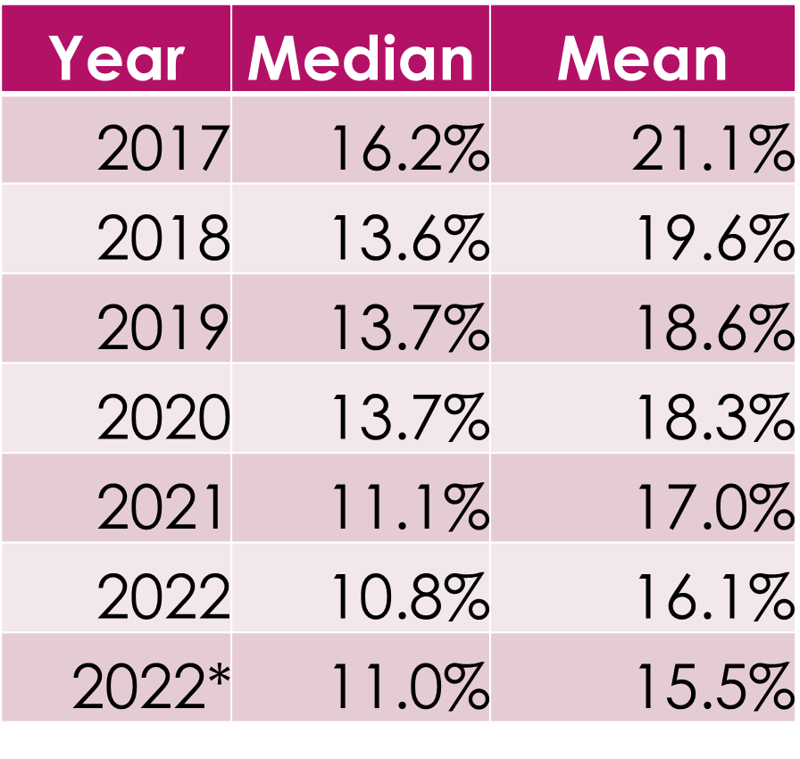
Gender Pay Gap
The University is legally required to report annually on our gender pay gap (GPG). The median GPG of 11.0% in men’s favour has reduced by 5.2% since our first report in 2017. The mean GPG in men’s favour of 15.5% has reduced by 5.6% compared to 2017.
The Academic median GPG has decreased since 2021 from 11.1% to 2.8% and from 11.3% to 8.4% for the mean. The Professional Services median GPG has increased since 2021 from 5.7% to 6.6% and has remained at 8.3% for the mean. The impact of including the hourly paid staff in 2022 has reduced the mean GPG from 16.1% to 15.5% and increased the median GPG from 10.8% to 11.0%. We now have a new baseline for future years that is inclusive of hourly paid staff and we remain committed to eliminating the GPG by 2030.

A note on pay gaps: Pay gaps are indicators of inequality in the workplace, reflecting the consequences of uneven distribution and representation. The mean and median are measures of central tendency within data sets, used as an industry standard to analyse pay gaps. The mean is the average of a set of numbers. It is calculated by adding up all of the values in a data set, and then dividing by the total number of values. The median is the middle value of a set of numbers. It is calculated by ordering all of the values in a data set from lowest to highest and identifying the middle value. As of March 2022, and in line with statutory guidelines, our pay gap calculations now include hourly paid staff. Closing pay gaps is primarily about building a more inclusive and flexible work culture with diversity of representation at all levels of the organisation. Equality legislation requires the University to publish annual gender pay gap reports. The University also publishes annual reports on ethnicity pay. To access full reports, please follow this link
https://www.bristol.ac.uk/inclusion/governance-policy-and-guidance/gender-pay-gap-reporting/

Representation of Female Professors
At 34% female professors we have exceeded the target set previously (33%). This compares to professorial representation across the sector of 28.5% female and 71.5% male. We are now aiming for 50% of professors to be female by 2030, also supporting our commitment to eliminate the GPG by 2030. 93% of the female professor population at UoB is white, meaning it is vital to adopt an intersectional approach where ethnicity is also considered in any future work to improve gender balance.

The expansion of the Academic Career Promotions process to include all levels of the academic pipeline, replacing the former time-served process, will hopefully help with reaching this goal. Our data continues to show that when they apply female applicants are more likely to be promoted than male applicants.

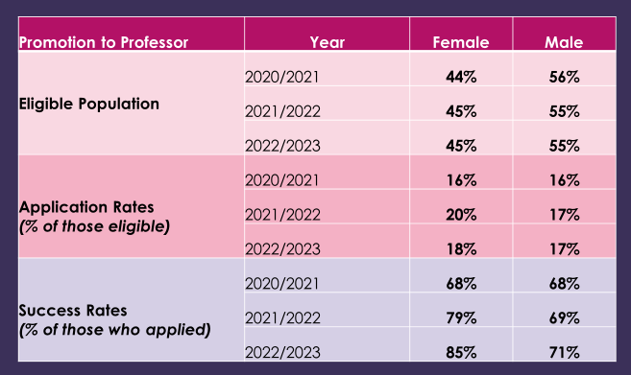

We continue to monitor male and female representation at Senior Lecturer and Associate Professor levels, ensuring we have a healthy pipeline of female talent feeding into professorial roles.

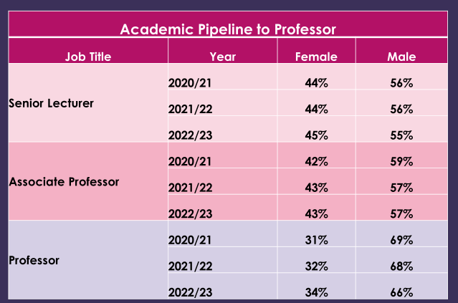

Staff Diversity
AGE

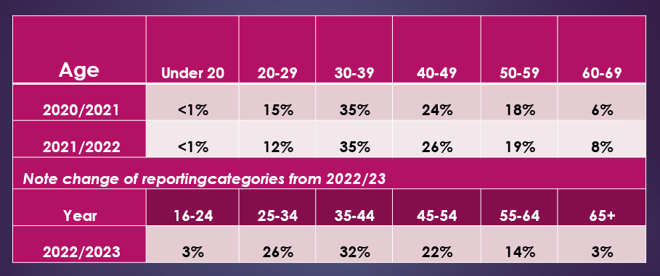

- The majority of our staff are aged 35 and over, with the highest proportion falling within the 30-39 age bracket.
- New reporting categories introduce in 2022/23 set a baseline for future monitoring.

Sector comparison, HESA data 2021/22:
- The highest proportion of staff across the sector fell within the 36-45 age bracket (28%).
- Staff were distributed across other age ranges as follows: 26–35 (24%); 46-55 (24%); 46-55 (24%); 56-65 (16%); 16-25 (5%); 66+ (3%).

DISABILITY

- The proportion of staff who disclose a disability continues to increase year on year.
- Staff are periodically reminded to review and update their diversity data, with a recent communication in June 2023 having a particular focus on disability resulting in more staff disclosing as disabled than ever before. This does not necessarily mean an increase in disabled staff: it may indicate that we are creating a safe and supportive environment where existing staff are more willing to share this information.
- 71.8% of staff who have disclosed as disabled are based in Professional Services; 28.2% of staff who have disclosed as disabled are academic.
- Most commonly disclosed impairment types were specific learning disability (31%); mental health condition (28%); long-standing illness of health condition (25%):
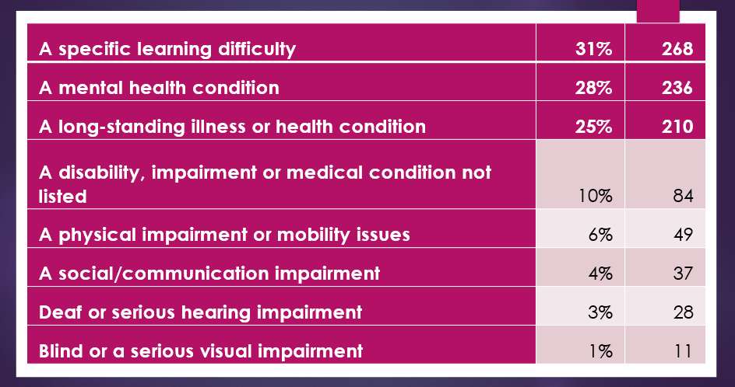
Sector comparison, Advance HE 2022 Report:
- Overall, 6.0% of staff disclosed as disabled in 2020/21; the disability disclosure rate for UoB (10%) is higher than the sector average.
- Most commonly disclosed impairment types were a long-standing illness or health condition (23%) or a specific learning difficulty (22%).
- More than one in eight disabled staff disclosed a mental health condition (16%).
- The most common types of disability disclosed at the University align with the sector, with the highest proportion of our staff disclosing under the categories of specific learning difficulty, mental health condition and long-standing illness/health condition.

ETHNICITY

- These data are based on known ethnicity and represent 92% of our staff population: 8% of our staff have not shared their ethnicity. Within this 8%, 51% responded that they ‘prefer not to say’, and 49% have not responded.

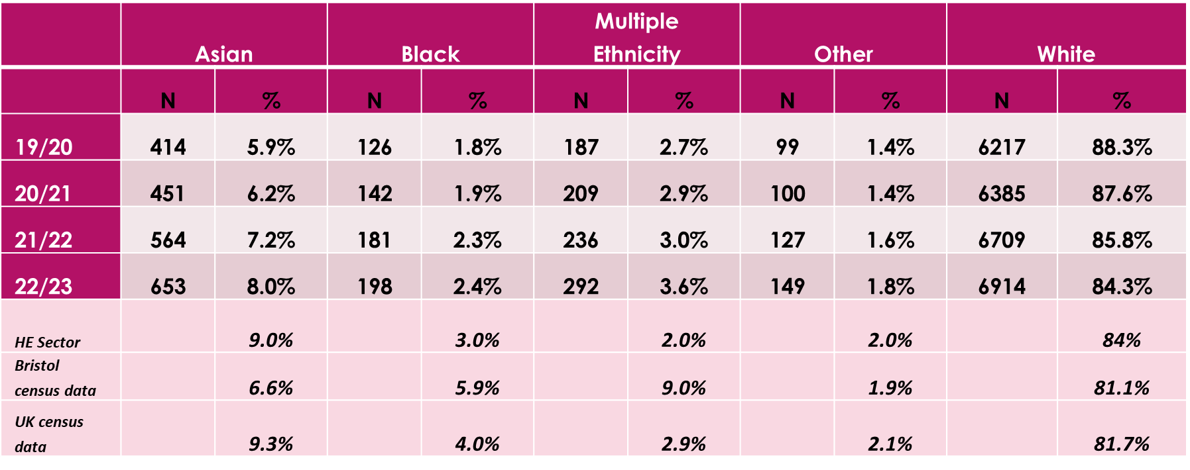
- Overall representation of staff who disclose as Black, Asian, multiple ethnicity or other minority ethnic background has increased from 11.7% in 2019/20 to 15.8% in 2022/23, however there are variances across each reporting category.
- Predominantly targeted at Professional Services staff, since the central EDI Team launched its Diversify initiative in 2019/20 (comprising targeted apprenticeships, guidance on positive action and inclusive recruitment, and a programme of employment outreach), representation of staff who identify as ethnicities other than white has increased by 56.4%.
- White staff remain in the majority at 84.3%, which is aligned with the sector average.
- Although numbers of Black staff have increased by 57% since 2019/20, representation remains low, and is also low across the sector, particularly when compared with census data. We are therefore aiming for representation of Black staff between 4% and 6%, to reflect the UK and Bristol population respectively.

Academic staff
Data on academic staff are based on known ethnicity, with a disclosure rate of 91.4%

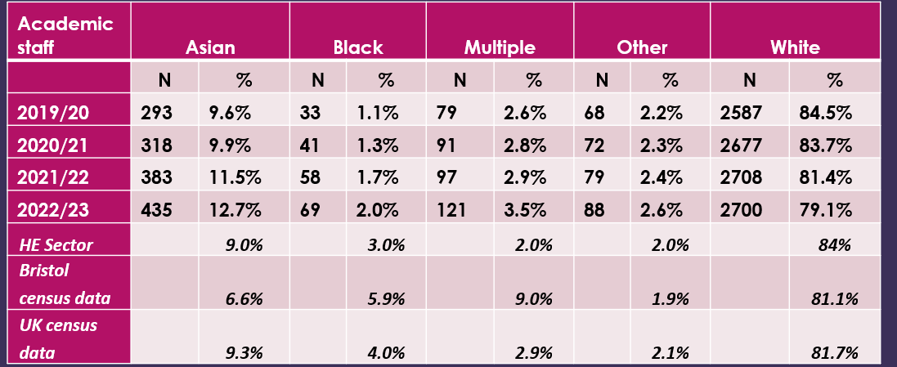

Academic Staff (non-clinical) by ethnicity and level over time by year | Asian | Black | Multiple Ethnicity | Other Ethnicity | White
Level A
19/20 | 14.2% | 1.6% | 3.6% | 3.0% | 77.6%
20/21 | 14.4% | 2.1% | 3.7% | 3.4% | 76.4%
21/22 | 18.6% | 3.5% | 3.8% | 3.2% | 71.0%
22/23 | 22.2% | 3.5% | 4.7% | 4.1% | 65.6%
Level B
19/20 | 11.7% | 2.0% | 3.4% | 1.9% | 81.0%
20/21 | 11.6% | 2.4% | 4.0% | 1.9% | 80.1%
21/22 | 14.3% | 2.6% | 3.4% | 2.6% | 77.1%
22/23 | 14.1% | 3.8% | 3.9% | 3.2% | 75.0%
Level C
19/20 | 10.2% | 0.7% | 1.8% | 2.0% | 85.3%
20/21 | 10.8% | 0.7% | 2.6% | 2.1% | 83.8%
21/22 | 10.9% | 1.3% | 2.8% | 2.6% | 82.4%
22/23 | 12.6% | 1.4% | 5.4% | 2.5% | 78.1%
Level D1
19/20 | 5.6% | 1.1% | 2.8% | 2.6% | 87.9%
20/21 | 5.3% | 1.1% | 3.0% | 2.3% | 88.3%
21/22 | 5.8% | 1.2% | 3.2% | 2.8% | 87.0%
22/23 | 7.4% | 1.1% | 3.0% | 2.5% | 85.9%
Level D2
19/20 | 4.3% | 0.0% | 1.2% | 1.2% | 93.3%
20/21 | 5.8% | 0.0% | 1.2% | 1.2% | 91.9%
21/22 | 7.2% | 0.5% | 3.6% | 0.5% | 88.1%
22/23 | 7.7% | 0.9% | 3.2% | 1.4% | 86.9%
Level E
19/20 | 5.0% | 0.2% | 1.3% | 1.0% | 92.5%
20/21 | 5.6% | 0.2% | 1.2% | 1.0% | 91.9%
21/22 | 5.6% | 0.2% | 1.4% | 1.2% | 91.7%
22/23 | 5.2% | 0.2% | 1.3% | 1.2% | 92.1%
Clinical
19/20 | 10.1% | 0.5% | 1.4% | 3.4% | 84.6%
20/21 | 10.6% | 0.4% | 1.3% | 3.5% | 84.1%
21/22 | 10.7% | 0.5% | 0.9% | 2.8% | 85.1%
22/23 | 12.5% | 0.5% | 1.0% | 2.0% | 84.0%

- UoB is broadly in line with sector averages (which are low) in relation to representation of academic staff, with the exception of professorial staff, where we see a higher than average proportion of white staff (92.5%) compared to a sector average of 88.5%.
- The majority of Black academic staff at UoB are at academic levels a (Research/Teaching Associate: 34.3%) and level b (Lecturer/Senior Research Associate: 41.7%).
- Representation of Black academic staff remains low across the sector, with many institutions focused on interventions across the academic pipeline to support researchers from Black heritage, particularly researchers making the transition from postgraduate to early postdoctoral stages. These interventions also respond to the persistent structural inequalities that disadvantage people from Black heritage, including existing barriers within education, higher education and academic research.
- We will be closely monitoring the representation, progression and promotion of Black academic staff taking action to address any gaps or barriers.

Professional Services staff
Data on Professional Services staff are based on known ethnicity, with a disclosure rate of 93.2%

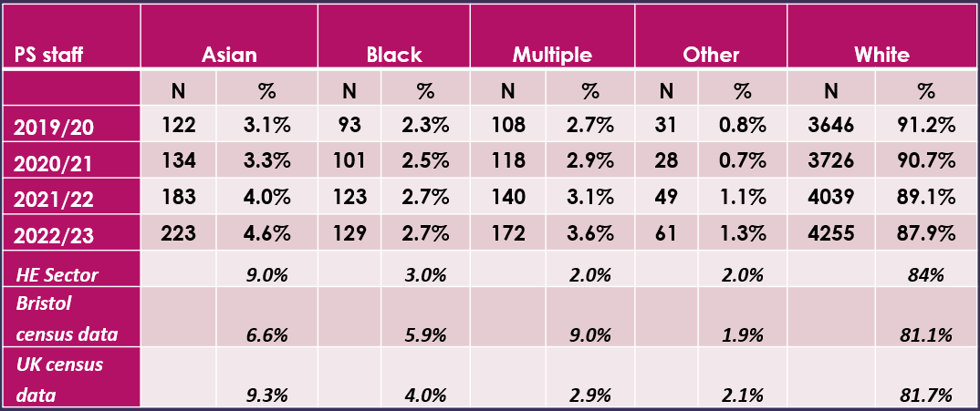

Professional Services Staff by  Grades A to H and ethnicity  over time | Asian | Black | Multiple Ethnicity | Other Ethnicity | White
Grade A
19/20 | 4.5% | 9.1% | 1.0% | 1.0% | 84.3%
20/21 | 4.3% | 11.2% | 1.6% | 1.1% | 81.8%
21/22 | 5.7% | 15.1% | 2.6% | 1.6% | 75.0%
22/23 | 4.6% | 14.9% | 3.1% | 2.6% | 74.9%
Grade B
19/20 | 6.0% | 8.4% | 2.4% | 1.2% | 82.0%
20/21 | 6.9% | 8.1% | 4.0% | 1.2% | 79.8%
21/22 | 9.9% | 7.1% | 4.4% | 2.2% | 76.4%
22/23 | 8.9% | 9.5% | 5.9% | 2.4% | 73.4%
Grade C
19/20 | 1.5% | 2.3% | 5.3% | 0.8% | 90.1%
20/21 | 2.6% | 2.6% | 6.1% | 0.9% | 87.8%
21/22 | 4.0% | 4.0% | 5.6% | 0.8% | 85.5%
22/23 | 5.0% | 4.2% | 4.2% | 0.8% | 85.8%
Grade D
19/20 | 6.6% | 2.6% | 5.2% | 0.4% | 85.2%
20/21 | 4.5% | 2.7% | 3.8% | 0.8% | 88.3%
21/22 | 8.1% | 3.8% | 2.5% | 2.1% | 83.5%
22/23 | 10.7% | 2.5% | 4.1% | 2.1% | 80.6%
Grade E
19/20 | 4.4% | 2.8% | 4.0% | 2.4% | 86.5%
20/21 | 6.4% | 3.0% | 3.9% | 2.1% | 84.5%
21/22 | 6.4% | 3.2% | 4.8% | 0.8% | 84.8%
22/23 | 7.1% | 2.9% | 3.7% | 0.8% | 85.5%
Grade F
19/20 | 2.8% | 1.9% | 3.6% | 0.2% | 91.6%
20/21 | 2.7% | 1.5% | 4.0% | 0.2% | 91.6%
21/22 | 3.3% | 1.1% | 3.8% | 0.7% | 91.2%
22/23 | 5.0% | 1.4% | 5.0% | 1.3% | 87.4%
Grade G
19/20 | 2.9% | 1.2% | 1.5% | 0.7% | 93.7%
20/21 | 3.6% | 1.7% | 2.6% | 0.7% | 91.5%
21/22 | 3.0% | 2.8% | 3.0% | 1.2% | 90.0%
22/23 | 4.0% | 2.6% | 3.5% | 1.3% | 88.7%
Grade H
19/20 | 2.0% | 1.5% | 1.7% | 0.4% | 94.5%
20/21 | 1.7% | 1.7% | 1.8% | 0.3% | 94.5%
21/22 | 2.3% | 1.6% | 2.5% | 0.7% | 93.0%
22/23 | 3.0% | 1.7% | 3.6% | 0.6% | 91.1%
Professional Services Staff by  Grades I to M and ethnicity  over time | Asian | Black | Multiple Ethnicity | Other Ethnicity | White
Grade I
19/20 | 3.2% | 1.9% | 2.4% | 0.5% | 91.9%
20/21 | 3.1% | 2.3% | 2.1% | 0.3% | 92.2%
21/22 | 3.0% | 1.3% | 2.4% | 1.3% | 92.1%
22/23 | 3.6% | 1.7% | 2.5% | 1.5% | 90.8%
Grade J
19/20 | 1.6% | 2.3% | 2.8% | 1.4% | 91.9%
20/21 | 2.2% | 2.2% | 2.9% | 0.9% | 91.8%
21/22 | 4.2% | 1.7% | 2.9% | 0.8% | 90.4%
22/23 | 4.6% | 1.7% | 3.3% | 1.0% | 89.3%
Grade K
19/20 | 2.7% | 0.5% | 1.9% | 1.1% | 93.8%
20/21 | 4.2% | 1.0% | 1.3% | 1.3% | 92.2%
21/22 | 4.4% | 2.1% | 1.4% | 1.6% | 90.4%
22/23 | 3.2% | 1.5% | 1.7% | 1.7% | 91.8%
Grade L
19/20 | 1.2% | 0.0% | 3.1% | 0.6% | 95.1%
20/21 | 1.1% | 0.0% | 3.8% | 0.5% | 94.6%
21/22 | 1.5% | 0.5% | 3.6% | 0.5% | 93.8%
22/23 | 1.8% | 1.4% | 2.3% | 0.5% | 94.1%
Grade M
19/20 | 1.4% | 0.0% | 1.4% | 0.0% | 97.2%
20/21 | 1.3% | 0.0% | 1.3% | 0.0% | 97.4%
21/22 | 1.2% | 0.0% | 1.2% | 0.0% | 97.6%
22/23 | 4.0% | 0.0% | 2.0% | 0.0% | 94.0%
- Representation of Professional Services staff who identify as ethnicities other than white is improving, increasing from 8.9% in 2019/20 to 12.2% in 2022/23.
- Since the central EDI Team launched its Diversify initiative in 2019/20 (comprising targeted apprenticeships, guidance on positive action and inclusive recruitment, and a programme of employment outreach), the number of Professional Services staff who identify as ethnicities other than white has increased by 65%.
- Testament to our work to position the University as a local employer of choice, the number of Black staff across Professional Services has increased by 38.7% since 2019/20.
- Arguably, Professional Services roles are more likely to attract local applicants, and yet representation at the University is below census data for the city.
- Across Professional Services the majority of Black staff (23%) are at the bottom of the structure on Grade A. This is influencing the pay gap for Black staff which currently stands at 21% median and 25.5% mean.
- We will be closely monitoring the representation and distribution of Black staff across our grading structure and taking action to address any gaps or barriers.
- We have set a baseline for future monitoring of all staff by the protected characteristics of ethnicity and sex:
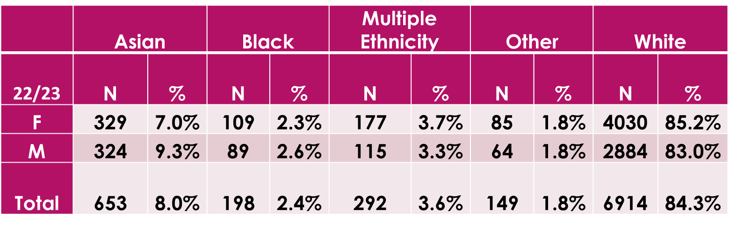

We continue to compare the ethnicity of Professional Services staff with ethnic groups across the city.
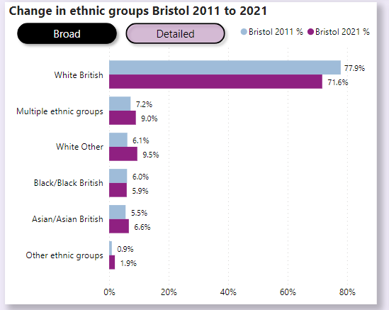

GENDER IDENTITY
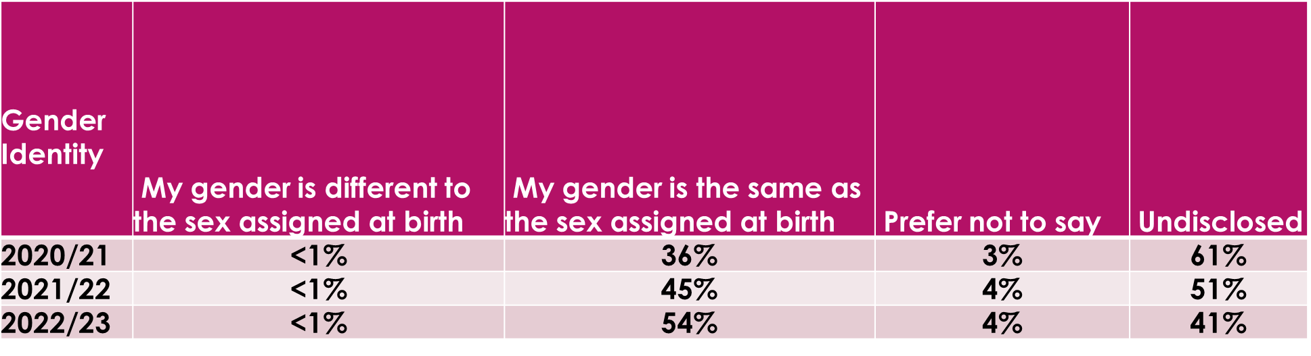

- Introduced in 2018, gender identity (or trans status) remains a relatively new diversity monitoring category.
- 59% of staff have shared their gender identity, with the majority (54%) disclosing their gender as the same as the sex assigned at birth; 4% preferring not to share this information; and less than 1% disclosing that their gender is different to the sex assigned at birth.
- The reporting category of gender identity refers to people whose gender identity is not the same as the sex they were registered at birth.
- Our data are broadly in line with the sector.

Sector comparison, Advance HE 2022 Report:
- Across the sector, 56% of staff disclosed that their gender identity is the same as sex assigned at birth; <1% disclosed that their gender identity is different from that assigned at birth; 4% prefer not to say; and 40% were undisclosed.
GENDER

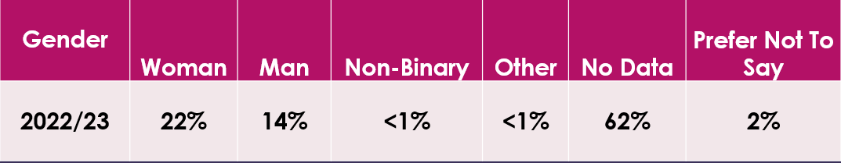

- 38% of staff have shared their gender with UoB.
- As a newly introduced diversity monitoring category, we will continue to monitor gender and take steps to improve disclosure rates over the coming year.
- Data in this annual report will establish a baseline for future reporting.

RELIGION OR BELIEF

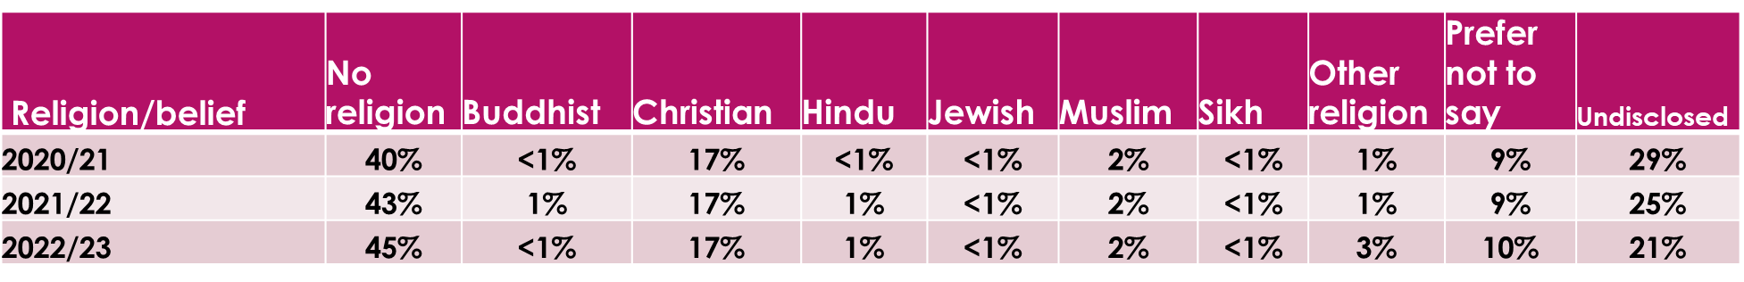

- 79% of staff have made a disclosure under the diversity monitoring category of religion/belief.
- The majority of staff at Bristol disclose as having no religion.

Sector comparison, Advance HE 2022 Report:
- The disclosure rate for staff across the sector was 70%: No religion 31%, Buddhist <1%, Christian 18%, Hindu 1%, Jewish <1%, Muslim 2%, Sikh <1%, Spiritual <1%, Any other religion or belief 2%, Prefer not to say 9%, Undisclosed 30%.

SEX
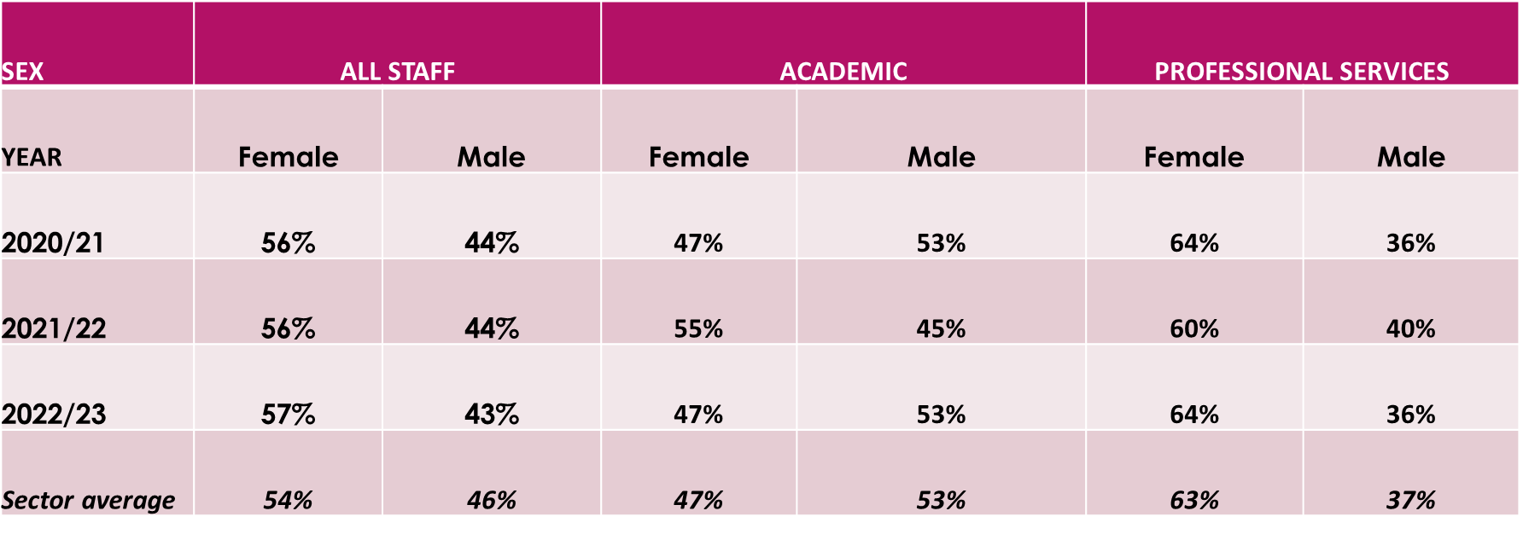
- 57% of all staff are female; 64% of Professional Services staff are female; 47% of academic staff are female.
Sector comparison, Advance HE 2022 Report:
- The University has a higher proportion of female staff (57%) overall when compared with sector data (54%), and a slightly higher proportion of female staff across Professional Services.
- Representation of female academic staff is aligned with the sector average.

SEXUAL ORIENTATION
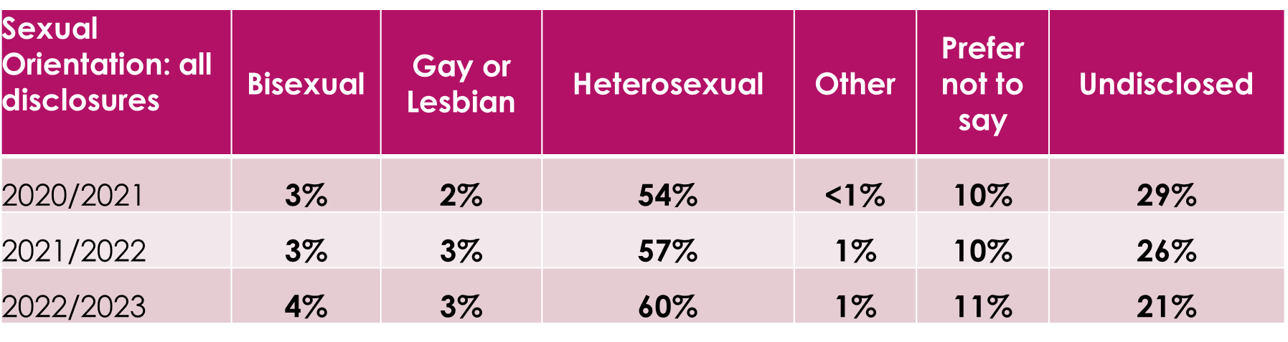
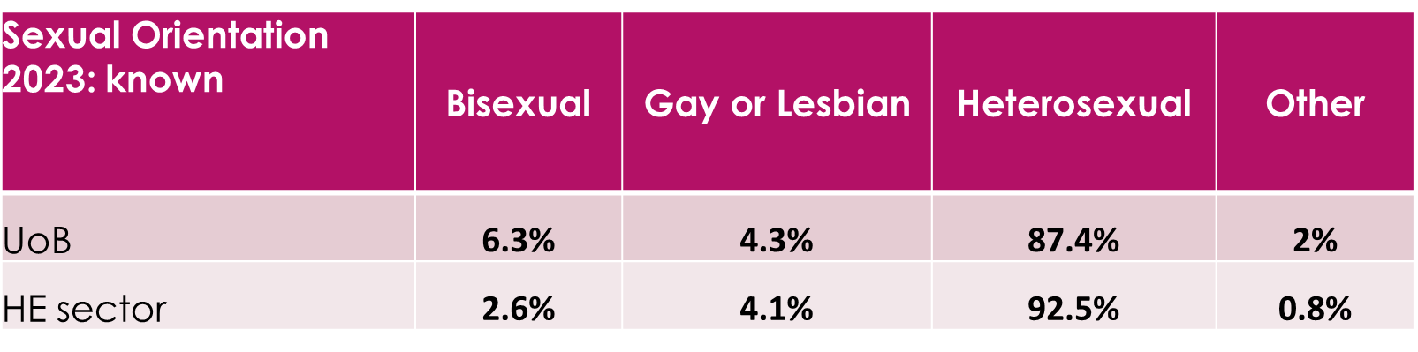

- 79% of staff have made a disclosure under the diversity monitoring category of sexual orientation.
- Of those staff, 68% have shared their sexual orientation with the University and 11% indicated that they preferred not to share this.

Sector comparison, Advance HE 2022 Report:
- Across the sector, 49.5% of staff have shared their sexual orientation, meaning that Bristol has a higher than average disclosure rate.

