A Walk in the Park:

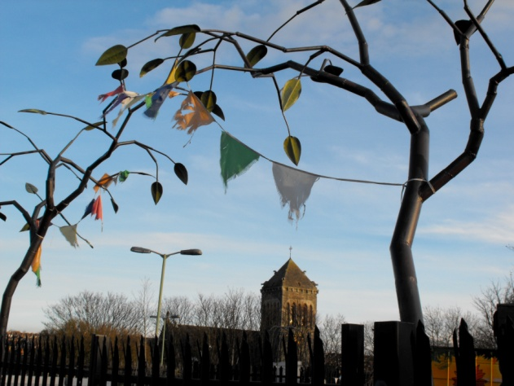

Understanding patients’ context
plus
examples of students’ creative responses to home visits

Dr Jessica Watson, G.P.

Thursday, 24th March

7.30–8.45 p.m.

Seminar Room, 39, St. Michael’s Hill, BS2 8DZ

Programme

7:15 p.m. Coffee/tea
7.30 p.m. Presentation & discussion

All welcome

To book, please e-mail: tricia.thorpe@bris.ac.uk

A Walk in the Park: abstract

Teaching first year medical students in a deprived and ethnically diverse inner city area I spend one session walking around the local area with them, visiting mosques, synagogues, local cafes, shops and parks.

I will share my experiences of this novel approach to teaching. We will discuss how to make this into a powerful learning experience and how similar ideas can be applied to your teaching setting.

I will also share some of the creative pieces produced by first year medical students in response to their experiences.

