Dashkova tour of Bristol, French in Russia Conference, September 2012

Note: references below to ‘extracts’ from Dashkova’s account of her trip to England can be found on another document on the conference website.

Introduction
Dashkova visited Bristol as part of a fortnight-long trip in late October 1770 as a side-trip from London and wrote an account of the trip in Russian, probably the year after, in the guise of a letter to a friend. The account was published in a journal in 1775, and is thought to be the first such travel account of a trip to Britain published in Russian. Dashkova wrote another account in French about a trip to Scotland in the 1780s, thought to have been composed as a genuine letter to her Irish friend Mrs Morgan.

Dashkova undertook the trip to the West Country with her cousin, daughter and governess. By horse and carriage they visited towns, sights and country estates around the South and South-West of England, including Southampton, Winchester, Stonehenge, Blenheim, Bath, Bristol, Oxford and Windsor. Every day they set off early, by 7 or 8 am, with the itinerary packed with sight-seeing, events and meetings. They must have travelled at quite a pace to fit so much in during only two weeks. Dashkova could have sped up the schedule to make the tale more interesting, although many of the details are accurate. She is very specific about times, distances and where they stopped, even at the smallest villages where horses were given a rest. Awkward transcription of place names into Russian perhaps shows that Dashkova picked these up in passing from a guide or locals. Dashkova is generally impressed by what she sees, in keeping with her overt anglophilia, but with some characteristically harsh criticism thrown in. Her main interests are in architecture, gardens, art, history, customs and geography of the land.

Bristol
Bristol was in its heyday at the time of Dashkova’s visit. It became England’s second biggest city by the mid-eighteenth century (the population increased from 20,000 in 1700 to 50,000 in 1750), mainly due to imported goods, including sugar, tobacco and slaves from Africa. In the nineteenth century, after the slave trade ended, the success of Bristol’s port was beginning to decline. The city suffered from bomb damage during World War II. Bristol is now England’s sixth-largest city. | 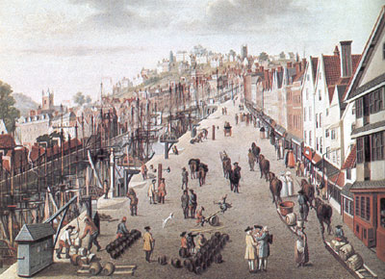  The port of Bristol in the eighteenth century

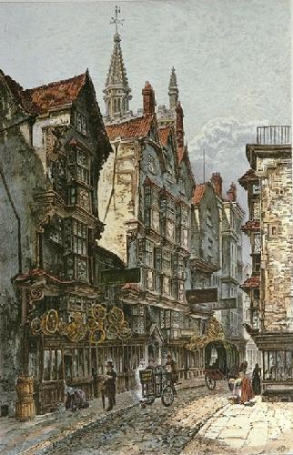  St Mary-le-port St., Bristol, eighteenth century | Key Bristol dates before and after Dashkova’s visit  http://www.localhistories.org/bristol.html - a brief online history of Bristol  Red Lodge built 1590. Bristol Castle destroyed 1650. St Nicholas Market built 1743. The first bank in Bristol opened 1750. Theatre Royal built 1766. New toll bridge built 1768.  Dashkova’s visit in 1770  In 1784 John Palmer established the first mail-coach service, from Bristol to London. The overnight journey took 17 hours.  Georgian House built 1788. Blaise Castle House built 1796-98. An old windmill was converted into an observatory with telescopes in 1828. SS Great Britain built 1843. Cabot Tower erected 1897. Wills Memorial Building built 1914.  Suspension Bridge: in 1753 a Bristol wine merchant, William Vick, left £1,000 in trust in order that when the fund had grown to £10,000 it should be used to build a bridge. The design competition in 1829 was judged by Thomas Telford. Foundation stone laid in 1831.  Dashkova’s account of her trip to Bath and Bristol  Dashkova’s party travelled to Bristol for the day from Bath in two carriages (see extract on other tour document about highwaymen).  They stayed in Bath for a few days where they were surprised to be greeted by bells. They visited the baths and pump, and sampled the water. They walked around squares, parades, and had communal breakfast in big hall. In the evening they attended a concert by a singer and an oboist, then went on to a ball. They also visited a country house outside Bath.  Dashkova found Bristol ‘cramped and dark’ despite being a key commercial town of England (see extract about Bristol).

Dashkova tour of Bristol: itinerary

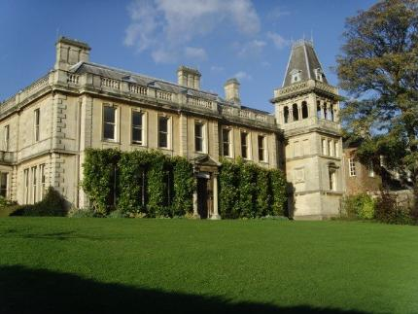  Goldney Hall of Residence (University of Bristol) today | - Goldney Hall (see extract about English gardening)  http://www.bristol.ac.uk/goldney/goldneyhallhistory/
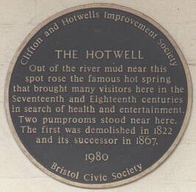 | From Goldney Avenue along Goldney Avenue/ Cornwallis Crescent (or Regent St., Royal York Cescent) to site of former pump room with view of Clifton Suspension Bridge (which, of course, did not exist in Dashkova’s day)  - Hotwells – pump room (see extract about tasting the water)  http://www.about-bristol.co.uk/wat-01.asp
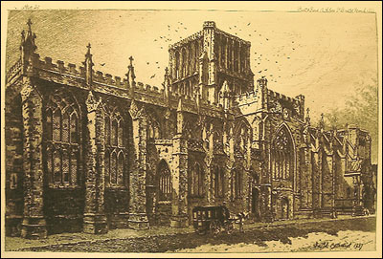  Eighteenth-century view of Bristol Cathedral | Along Hotwells Road (used to be lined with ‘country houses’ in Dashkova’s day, if this is the road she means) to Cathedral  - Bristol Cathedral (extract – ‘nothing worthy of comment’)  http://www.bristol-cathedral.co.uk/index.php?id=17
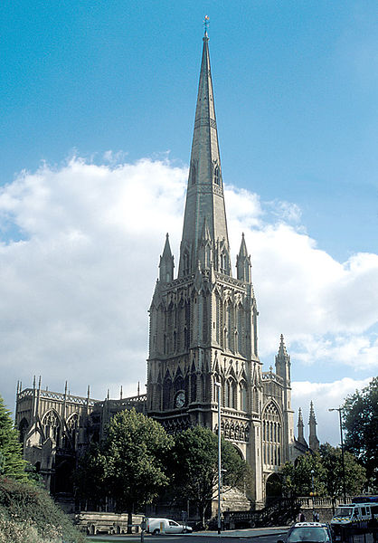  St Mary Redcliffe | From Cathedral via centre and Queen Square to St Mary Redcliffe  - St Mary Redcliffe  ‘the fairest, goodliest, and most famous parish church in England’ (Elizabeth I)  http://www.bristol-link.co.uk/history/st-mary-redcliffe.htm  From St Mary’s back via Queen Square to St Nicholas St.  - Hogarth triptych (1756) from St Mary Redcliffe now in offices of Bristol Council Archaeology Dept, St Nicholas Church, St Nicholas St.  http://www.bbc.co.uk/news/uk-england-bristol-13843758 - BBC news item about ‘unknown’ Hogarth triptych in Council offices
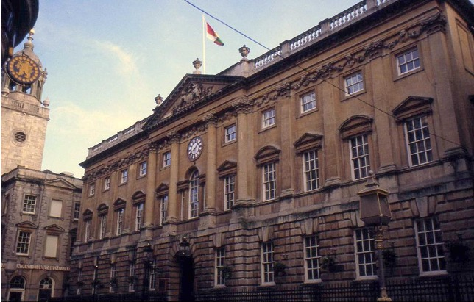  Corn Exchange, now part of St Nicholas Market | Walk to Corn Exchange  - Corn exchange http://en.wikipedia.org/wiki/The_Exchange,_Bristol
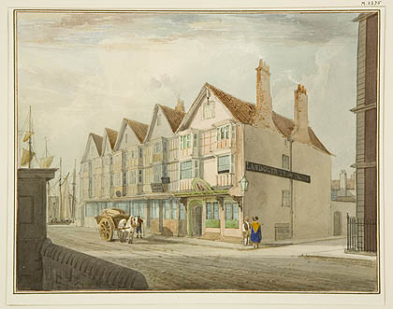  Llandoger Trow pub | Walk to King St. (Llandoger Trow, built 1664) or to Frogmore St. (Hatchet Pub)  http://judibee.hubpages.com/hub/Unusual-Historic-Pubs-in-Bristol  - English inn that existed in Dashkova’s time  (extract about ‘neat and ordered’ English inns)
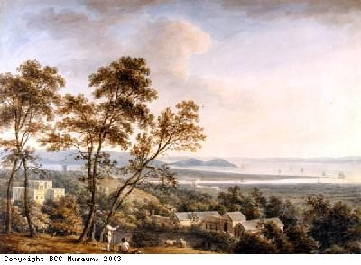  View over Kings Weston to the Bristol Channel by Nicholas Pocock (c.1785). Copyright BCC Museum | - Mr Southwell’s country house  For delegates wishing to visit after the conference if interested  During Dashkova’s visit the house was owned by twentieth Baron de Clifford and was undergoing renovation and extensions. There followed a few changes of hands: in the mid-nineteenth century it was owned by Bristol’s first millionaire; it became a hospital in WWI; then was bought by the Bristol Education Committee; subsequently the building was used as a police training centre; and has now been saved from dereliction as Kings Weston House, hotel and tea rooms just beyond Sea Mills.  http://www.kingswestonhouse.co.uk/history.html

Old maps showing Bristol in Dashkova’s day
http://maps.bristol.gov.uk/knowyourplace/ - Bristol Council website with different maps of various ages overlaid with information about historical sites
http://www.bristolreads.com/downloads/readers_guide/mapping_the_city.pdf - online leaflet about the history of mapping Bristol
- John Rocque’s 1750 map of Bristol with etchings of local sites http://www.vintage-maps.com/zoomify/template.php?zoomifyimage=10983_0.jpg
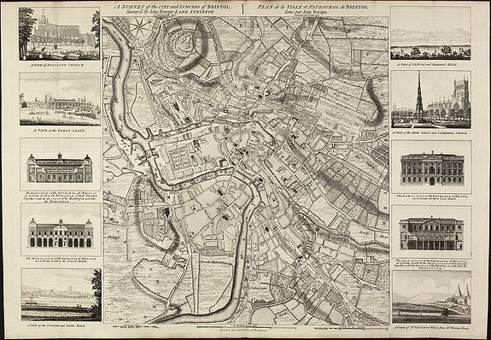
- John Rocque’s 1747 map of Bristol
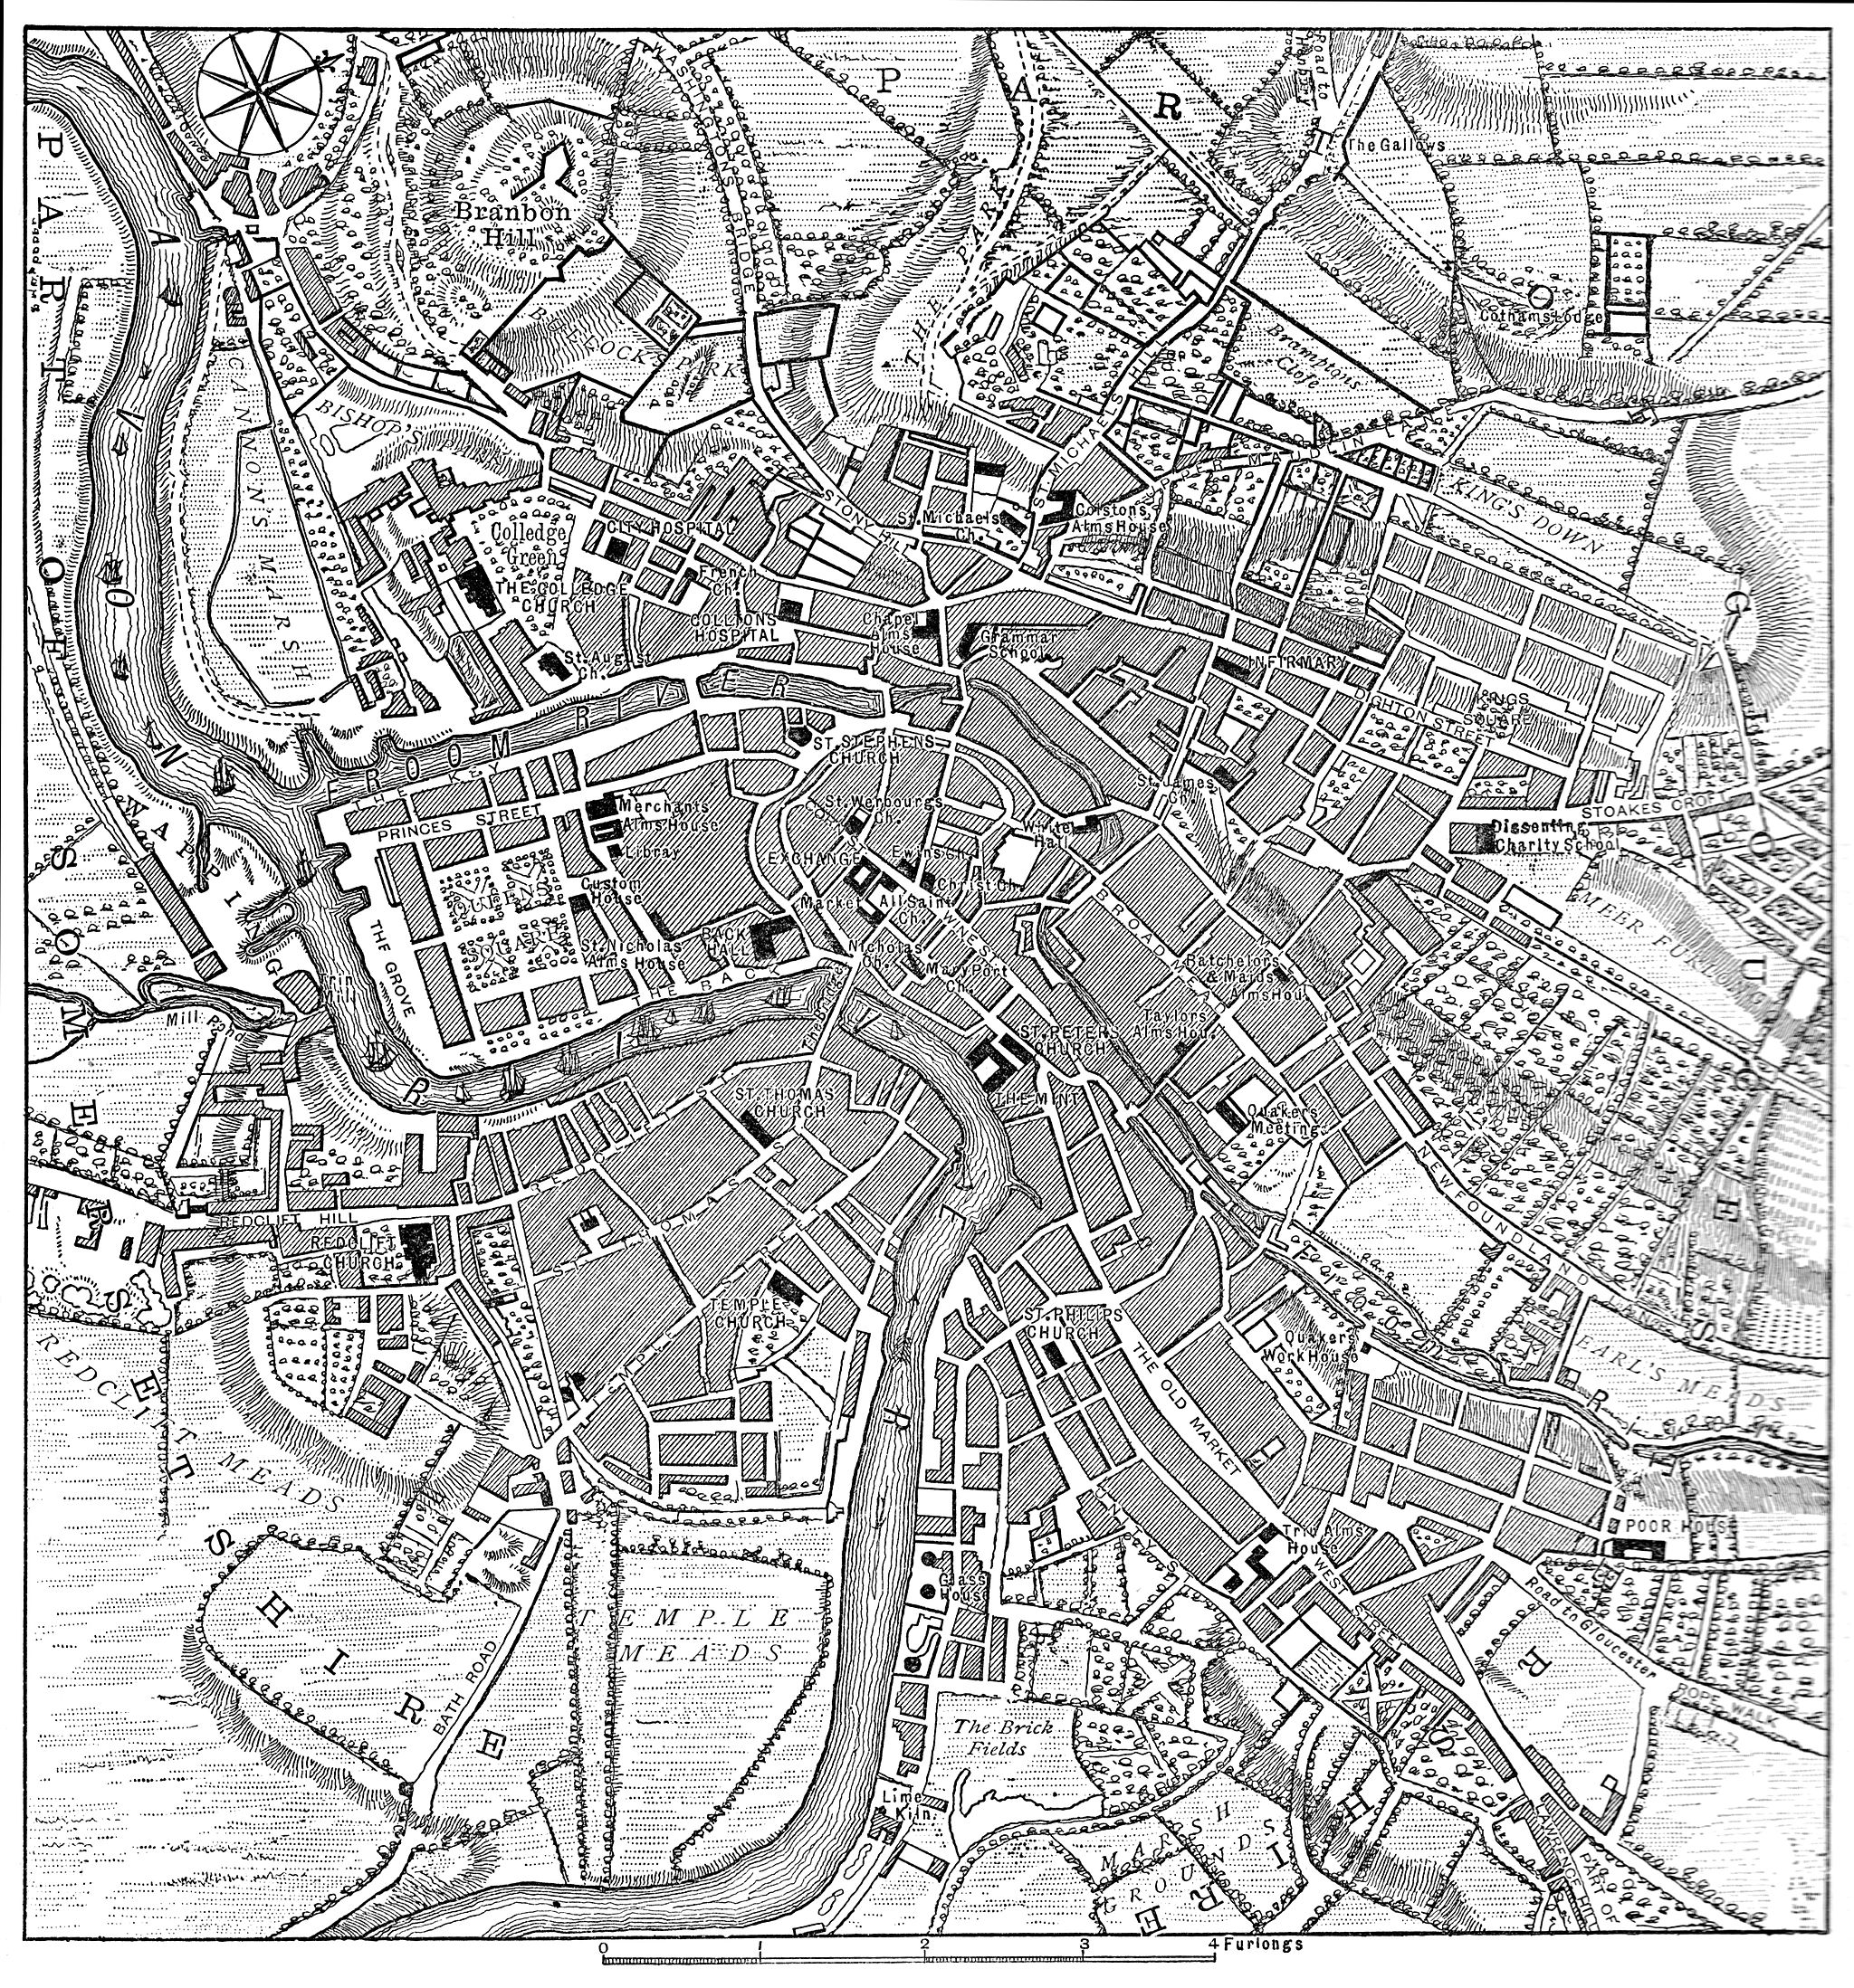

- 1767 road map from Bristol to Weymouth through Somerset and Dorset, the kind that Dashkova’s guides may have used for the trip. Waymarkers along the route were also important: Dashkova gives an account of the party getting lost because they were not able to see the waymarkers in the dark and of their having to spend the night at an impromptu stop.

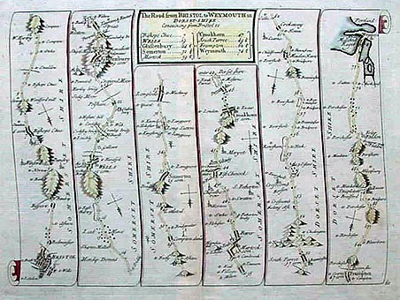

Maps showing route of the Dashkova tour of Bristol

